Session 1 MWWR

Case woman (pt of Michelle Hookham’s)
Wanted to come off antidepressants. Has h/o abuse. Feeling v vulnerable about joining the group. If she needs a break to let us know. She may discontinue the call…
Had many things over the years, but chronic terrible pain that is debilitating, on heavy painkilling meds wants to come off, Psychogenic in nature. Living with pain, discomfort.
Sexually assaulted as a young person and her sister was murdered . was v close to her, and her M was not v nurturing,… caused emotional distress, disconnected from M completely. M has now died, but same r’ship pattern with her chn, they have disconnected from her. Cause for lot of emotional distress… r’ship stresses. Many rx over the years for different states. Had problems with weight – had gastric sleeve. Pain has started from that point, but she says it started before that. pain has got pain. didn’t have it before. Said I would support and let her know if we need a break.

Rajan: what is happening, what is the problem?
Main issue, chronic pain for 15 years. Lower back, perineal region, R arm, leg as well.
TM @ pain it can change s/t deep throbbing pain other times a burning pain. it moves around, not in the same place all the time.
When it increases, decreases?
Gets worse if I get distressed about a/t. I fi haven’t had much sleep. Don’t’ get a lot if I sit for long periods of time…. if I stay in bed too long, trying to get to sleep.
What is the effect of this pain on you?
It stops me doing lot of things that I would normally have done – housework, job, travelling. Also emotionally, I feel irritable easily, I’m so uncomfortable. I take meds for the pain, goes against my brain, had to take for a long time now.
Stresses for you?
I have 2 older chn, who won’t have a/t to do with me. Tearful. In their 40s. older one – won’t have a/t to do unless they want money. They tell me what an awful mother I am, it’s hard, used to be v close to them.
I need to be perfect in e/t. my family used to always tell me, how fat and ugly and stupid I was. Now my chn. Do it too. I won’t be perfect, but maybe acceptable, but put a lot of pressure on myself to be perfect and I can’t be tears.
If I’m at work, if boss is grumpy, I think it’s s/t that I’ve done. I imagine that I will have to put up with difficult financial situations, another stressor as well.
Tell more about these stresses?
Lots of nightmares – stop me sleeping. When I don’t go to sleep, I don’t cope well, become forgetful and clumsy, make mistakes at home and work.
Nightmares s/o getting into my room or house, threatening me or hurting me or trying to protect chn, from being hurt. At one stage, would wake up feeling s/o in the room, or clothes being pulled off me – I thought I was going crazy. Went on for months. Had a rx which helped with that. when I’m stressed, stuff is happening.
Nature? I’m a people pleaser – I want people to like me, I always felt so unlikeable, what I was told as a child I thought I was fat, family told me I was fat and ugly. I was 14 before I realised that I wasn’t fat – saw pics of me as a child – I was normal, healthy, thin, fit little child. always trying to be kind to other people, do things for them, to make their lives easier. Even when I’m tired, angry, I try to make people happy…
TM about your nature?
I have done things where I help other people to my own detriment. Put myself in difficult financial situations. People label me a people pleaser. I rarely confront people, I don’t’ say a/t, I just take it. if people are angry, shouty, I freeze… then I blame myself, it must be my fault.
Don’t confront people? What do you do? what is your response?
I tend to freeze, apologise, even if not my fault. I might cry. I must be stupid, unworthy, not good as a person… put myself down.
Freeze, what do you mean?
As a kid, had to be careful what you said or did, didn’t know when you’d get beaten or hit. I would stay v still. If parents, sister or B – I would be v still, in case that set them off. So now if s/o is angry, I stay really still, and try not to set people off.
Freeze, what is the exp there?
Be very still, not make any movement, be very quiet, in case they get angry in case they start – in case I escalate the situation.
HDTF at that moment
Terrified (tears) that I feel v frightened. Shaky. My heart races. s/t I feel nauseated. Just scared. I think that they might hurt me so badly that I’ll die.
Tell me ore about your nature – talkative/silent, active/inactive.. tM about ourself
I’m sedentary now, but I used to be sporty, did long distance running, netball, vigoro, ran eveyr morning before my H went to work. But one morning I got followed by guys and I stopped running
I generally am v friendly with people. I have to put people at their ease in my job. Equally happy being alone, or with kind friends. No trouble talking – as Michelle can tell you. I am friendly – s/t I do feel shy. If I feel adequate – if I’m not as well educated, feel shy and not good enough…
What are you sensitive to?
Emotionally I am v sensitive to criticism. Esp from people I care about. Sensitive to being lied about – prefer cooler weather to hot. in summer, I feel exhausted and tired all the time. can be sensitive to some medications, foods – some dairy products can make me unwell
I can walk into the room and feel the atmosphere… I can tell if the bosses have had an argument. Does that make sense.
Fears? So many things! Scared of being homeless. Used to own our own home, then my sister died and incurred a lot of financial difficulties due to her death. Moved interstate. Haven’t owned a house in 20 years. We are getting older. How will we manage financially?
Scared of snakes… petrified of them, I nearly trod on them, always how venomous they were. I hate spiders, scared of the dary. Don’t’ like people jumping out and scaring me thinking it’s funny. Don’t’ like loud environments… I don’t like huge crowds of hundreds of thousands where I couldn’t get away if I needed to, if I chose.
Don’t keep bedroom door open at night, keep it closed and locked.
Scared of my oldest son now. Last time he visited me, pretended he was hugging, but he put his arm around neck squeezing… I froze. I would never be alone with him now. That makes me really sad.
I am scared not being able to financially support ourselves too.
Hobbies love reading. Could read before I started school. I like to grow my own food. I like knitting, stitching, embroidery. I like cooking and feeding people. I like giving to other people.
A/t you don’t’ like to do? I don’t like to sit out in the sun. I don’t’ like the summer sun, it makes me feel nauseated and faint. Like I might pass out.
Food and drink, what you don’t like?
Not fussed on bitter things, like olives, that I’ll eat, don’t like tripe or kidney, offal. Don’t like brussels sprouts or tofu,

WISE woman 1
I don’t like It, it’s scary. She is trying to get away from s/t. I don’t like looking at it at all. It’s ugly… get away from s/t evil and threatening, puts her in danger. She is afraid.
What is that? wanting to push back, away from s/t that is frightening.
Push back? she is avoiding – trying to move back, away from whatever has created this fear, and scaredness in her.
Forget the lady, just put your attention on these words… push back, avoid, back away
To become safe, move away from people, situations, places where I would be in danger or unsafe or threatened.
What would be the response, to back away, find s/w safe?
What would I do?
Imagine you are threatened or unsafe? the reaction?
I know from situations – in dreams, nightmares, I freeze. Ideal would be to get away, to physically remove myself from the situation, but I don’t. I haven’t in the past, and I don’t in dreams or nightmares either. I can’t. I’m frozen, I physically can’t move.
What happens then?
I am terrified… I am telling my legs MOVE! Tell arms to Move! But they don’t, can’t.
What is the inner exp, take your time you are unsafe, threatened, frozen, legs can’t move. What is the exact opposite?
It feels like I’m going to die. That I’m going to be killed. I will be killed, die, or be hurt really badly in some way.
Exp hurt?
Stabbed or choked, or shot. A really violent…
Exp to be stabbed, choked or shot? Exp physically?
I have been threatened with a gun, nearly choked a couple of times. Feelings at the time, threatened with a gun. Was just to freeze, be terrified, and be still and not create anything to cause the situation to be escalated. When son was choking me… I was frozen, just tapping on his arm… it’s making me feel like I’m going to die. I was tapping, I thought I would pass out or die.
Pass out? Faint, become unconscious?
Has it happened? I fainted once after BCG, after Vx and again after blood loss, when count was so low.
Close your eyes and bring such a situation to your awareness, when it comes, describe the sensation in your head, chest, arms and legs in such a situation. Emotionally I understand you will die, will be killed, but in the body, what is the sensation?
Head feels like it is swelling, like it will explode. Chest feels tight. Stomach is churning. Legs feel weak like they are trembling.
Chest like swelling up, like brain is really tight on the outside. Skin feels really tight. Like brain is pressed against bones of my skull. Feels like I can’t see properly. Though eyes are open, like I can’t focus, I can’t see what is happening.
Keep eyes closed, stay with physical states (repeat them all). Go deeper into this and tell more.
Heart pounds, hands, and arms get weak. Feels like body is sagging to the ground. I don’t know a/t else.
WISE woman 2 create a story around this one…
This person looks strong and scornful, telling s/o off. They are in control of themselves and what is happening to them. not afraid.
Tell a bit more Seems they are sure of who they are have confidence in themselves. She is s/o who can speak up for herself, not afraid to use her voice. Can take on a/o who threatened her.
Exact opposite of that person? s/o who is afraid and scared all the time, feels threatened and at risk.
Dreams from c’hood?
This one stuck with me. As a child, there was a paedophile who lived close, I was one that he assaulted on regular basis. Never went near older sister, but had dreams about him hurting younger sister. Had to protect her. We had dresses the same style, but diff colours. These dresses we had – he was trying to hurt my sister. As long as we had these dresses, I was terrified, that we’d be hurt. Couldn’t wait to grow out of them. still see the dresses, the style. He eventually did hurt her as well. I should have been able to protect her. In the dream, I had to be the strong person, make sure he never got to her the way he got to me. But I couldn’t I was just a kid. But that dream has stayed with me all my life.
What was dream, what was reality?
We were in a poor house. Near a window near kitchen, big water tank outside. You tried hard and could get through the window. He was trying to get through the window to my sister. We were wearing these particular dresses, it was significant for me. He was trying hard to get through the window. I thought we have to get rid of the dresses, then my sister would be safe. That was the dream.
What is the significance of the dresses?
I just recall us wearing them – I had to get rid of them… as long as we kept wearing those dresses, then she was in danger.
Dresses? They were quite pretty…
Exp in the dream? The window, he was trying to squeeze through?
I wanted to push him out the window, but I couldn’t I was a kid, he was big and strong. I have to stop him getting in, but I can’t stop him! I am not physically strong enough to do this.
What did you want to do? what was your response?
I wanted to kill him. I wanted to kill him!!! If I could kill him, we’d be safe.
When you say the word safe, describe? Unrelated to you.
Peace. To be at peace. Not under threat. to have a quiet life. to be free. To be able to be a child. and not know horrible things.
When you say safe, is there a place that come?
Not being beaten by parents… not being under my parents.
Safe? Not having to protect myself.
Protect? Unrelated to you? Out of context.
I can’t think what it means.
Protect? Watchful, being watchful. Being careful.
Exact opposite of safe, protect?
In danger.
TM about the pains, what is bothering most? Where, nature of the pain etc.
R side of my body, where it always is. Worse at night. worse when under stress. Comes and goes. Can be intense then 5 mins later, there is nothing. The pain s/t feels like nerve irritation. When you. Bump elbow and hit ulnar nerve, that awful feeling?
It feels like that in the labial area, goes for hours and hours. s/t feel it will drive me out of my mind, it feels so tense. Other times, nothing.
Character of the pain?
When you have irritated a nerve. Deep inside the labial area, nerve irritation. s/t a burning pain, in lower back labial area, down front of R leg. Up in the neck, down R arm, right down to my wrist.
Burning pain?
Feels like it’s on the skin, the outside of the skin. Nerve pain is more deeply buried. I don’t’ get that in limbs or lower back… just on the R labia.
Remains in one place or shifts?
It shifts – no, the burning pain shifts, the nerve pain is always in the same area.
Throbbing pain?
In lower back. down the back of the knee. s/t I could have some slight sciatic pain, s/t intense, but not frequent, that is infrequent.
What gives relief? I take narcotics for it. I tried medicinal marijuana. No relief. Made me feel disorientated, bit odd. Didn’t’ like that feeling. But I don’t like taking narcotics, in family there is addiction, drug abuse, it scares me, I’ve been taking these for so long.
Can you get v angry at some times?
Yes, last night I was really angry, swearing and ranting and raving.
Changes in your body then? Head, chest, hands, feet?
I don’t even notice the physical things, I am so caught up in verbalising.

Michelle: She really honed in on key points. She has skin sx, covered in moles and skin tags. Troubled her a lot – doesn’t mention any more. had skin tags on the face which were burned off. Have seen her r’ship break down with her chn. It’s all her – they think she has a personality disorder, but I haven’t seen that. pattern with her M has repeated with her chn. She belongs to a religion that is v strong. Has a religious practice – one day/week. Chn grew up in that church. Chn have rebelled and left the church, which is a problem.
Pains on R side. Might take panaden fort and endone.

Rx = BERBERIS 1M followed by LM 8

ANALYSIS
Five finger method:

5 FINGERS
- SUPERCLASS
- KINGDOM/SUBKINGDOM
- MIASM,
- CHARACTERISTICS
- KEYNOTES/SOURCE QUALITIES

SUPERCLASS
To do with the nature of the person.

KINGDOM/SUBKINGDOM
Seen in the sensitivity

MIASM,
Pace

CHARACTERISTICS
Peculiar sx which are found in the repertory

KEYNOTES/SOURCE QUALITIES
Keynotes are In MM, highlighted again and again by many authors
Source qualities can be identified in Google

So in this case:
she is mild,
she internalises all her problems.
Does not confront
Is timid
Her response is to pull back and freeze/find safety and protection
M said she may need a break, she may withdraw… to shut off, pull back. so we have to be very sensitive to this.
People pleaser
Weeping all the time. like pulsatilla

= SUPERCLASS 1
So e/t else needs to be seen in this context… you can’t jump to Solanaceae… from this moment on, is from the stand point of the SC1. This is the most important step. The correct perception by itself doesn’t indicate any SC, nor terror – it’s the person and the way that they respond – are they decisive or not? People pleaser or violating – confronting or non confrontational.
Once you have SC1 – every single SC has fear, threat, danger…. IT IS WHO THE PERSON IS, which determines the superclass.

KINGDOM/SUBKINGDOM
Seen in the sensitivity
If it is animal, then we would see a mollusc: I go into a shell and close down. This never came in the case. But I asked her many times, what would happen?
Something happened and there was a reaction…
If s/o is criticising, choking, entering the house… all situations, her response is to have palpitation, some reaction in the body … trembling – a complete response in terms of sensation. MANY sensations, brain enlarging, trembling etc. pounding of the heart
There is a circumstance and a response.
Not a mineral that I need a protector, can’t manage alone, not capable this is not what came through in crisis
Situations…
Something happens and response = plant kingdom
Subkingdom, we go to SBC1: Magnolidae

There are many families in SBC1 which will be similar to her, in one way or the other. The sensitivity to being criticized – this hurts her a lot.
Opium – terror, sensitivity to pain, suffering.
Sensitivity: can be very sensitivity, might be overwhelmed, too much for her…
Response of oversensitivity to make a distance between her and the problem, important part of Magnolidae.

Q: not enough strength to push the man out of the window: not mineral? Capability?
A: it’s a nervous response… legs are trembling – yu are reacting or responding to nervous stimulation

MIASM,
Pace
Focus here on the chief complaint… mainly see the pace in the chief complaint
it is chronic 15 years…
it is stuck with her.
It doesn’t kill her
Not life threatening
But off and on, the pain becomes very intense, needs to take pain killers. Pain goes away then recurs
Malarial miasm
The nature of the chief complaint shows you the miasm…

CHARACTERISTICS
Peculiar sx which are found in the repertory
It’s close to Ranunculales, but we don’t have to guess!
The rx must have
- Peculiar sensation that the brain is becoming larger, that will burst through the head.
- Pain in the labia
- Wandering or shifting pains … s/t here, s/t there. Not only in location, but also:
- Change in intensity quite rapidly
- Change in character

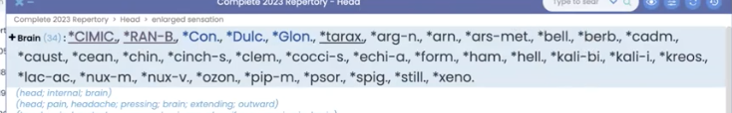

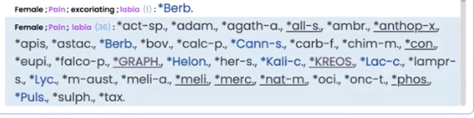

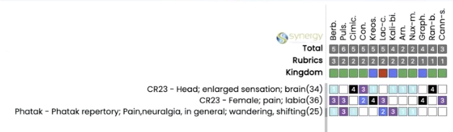

KEYNOTES/SOURCE QUALITIES
Keynotes are In MM, highlighted again and again by many authors
Source qualities can be identified in Google

Go to VQ and see that Berberis is part of the order of Ranunculales

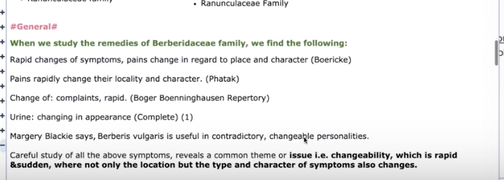

Rapid changes of sx – pains rapidly change their character…
Berberis:

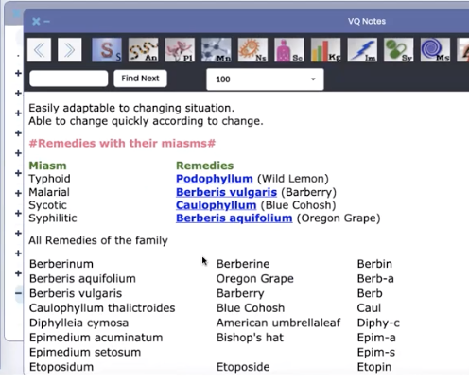
Berberis is malarial miasm.

Further confirmation.

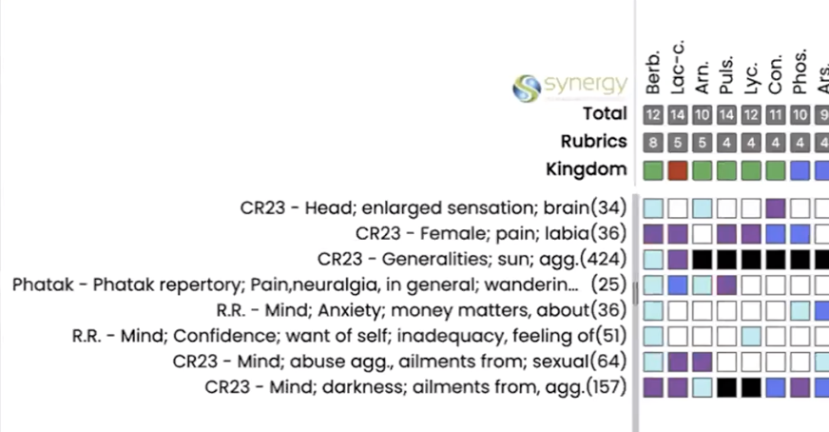
Ailments from sexual abuse…
And from dark.
Lot of terror.

Should receive Berberis – with pains and lot of threat feeling –
WISE: immediately goes to I can’t look at it… delusion level

BERBERIS 1M, then LM 8, daily.
Watch for a month and then evaluate.

Criticism sensitive to
Food, dairy - <<

