HTMA REPORT SUMMARY

FOR: Heather Maddocks DATE: 06.11.23

This treatment plan is based on an assessment of nutrient levels specific to your child.

METABOLIC TYPE

You are a FAST metabolic type. The higher the number (with 4 being the highest) the further away your metabolism is from being balanced and the risk of the following increases:

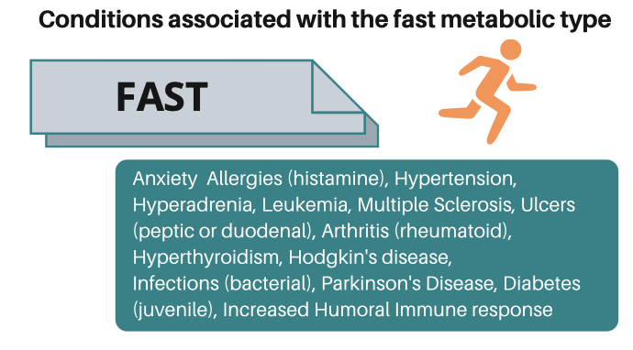

(Image copyright InterClinical Laboratories 2021)

THE MINERALS
Generally speaking, all nutrients should be in the white frame. In a perfect world, all nutrients will form a ‘picket fence’ with everything following the faint central line to show they are in just the right amounts for optimal health and balance.

The first 6 are the most important ones to focus on because of the impact on moods and energy. Each mineral works in sync with its partner and like to be in proportion, and also be balanced in comparison to other pairs.

- Calcium (Ca) and Magnesium (Mg) are sedating & calming nutrients.
- Sodium (Na) and Potassium (K) are stimulating nutrients because they help to produce energy.
- Copper (Cu) and Zinc (Zn) play a huge role in regulation of moods and energy. These 2 needs to always be in balance with each other, or there are obvious issues with behaviour and moods, and also gut and immune health.

Low calcium:
A sedating nutrient to help with more calm moods, and helps with getting to sleep. Will be prone to anxiety and/or depression.

Low magnesium:
Needed for sleep maintenance and to settle the mind. May notice bladder problems eg urinary urgency because muscle is stiff and can’t expand.

Low sodium:
Sodium is an electrolyte mineral and therefore needed to help with energy. As a stimulating nutrient, low levels mean you will feel exhausted. Will have digestive problems especially with protein and B12 metabolism.

Low potassium:
Potassium is an electrolyte mineral and therefore needed to help with energy. As a stimulating nutrient, low levels mean you will struggle with energy and likely have sweet cravings. Will have digestive problems and may be prone to constipation.

Low copper:
Can upset thyroid function when low, and typically energy seems low, or may notice easy bruising, may see signs of depression.

Low zinc:
Impacts on energy, mood, sleep, appetite, fussy eating and digestion. Can also mean skin issues, and digestive complaints such as flatulence.

Low iron:
If not due to menstruation, then low levels will be due to reduced digestive ability to extract the iron from foods. Low iron can also contribute to signs of depression.

Low manganese:
Valuable for supporting the body’s clearance of toxins including chemicals such as food additives. Reduces development of food intolerances. Needed for thyroid health, blood sugar regulation, and absorption of Calcium and Magnesium. Needed to convert thyroid hormone T4 to T3.

Low selenium:
Needed to support thyroid function for balanced energy production.

Low boron:
Likely due to low levels of calcium and copper. Boron is important for bone health and something to be mindful of in mature years.

Low molybdenum:
Valuable for supporting the body’s clearance of toxins including chemicals such as food additives. Reduces development of food intolerances.

Low sulfur:
Valuable for supporting the body’s clearance of toxins including chemicals such as food additives. Supportive of hormonal health. Reduces development of food intolerances.

THE RATIOS

Low Calcium (Ca): Phosphorus (P) = An indicator of overall energy production. Energy production is stimulated due to the lack of the sedating calcium in comparison to the stimulating phosphorus. Body and brain aren’t able to rest and recharge on a daily basis.

Low Sodium (Na): Potassium (K) = An indicator of adrenal function and resilience. Reduced capacity to handle stress. May also notice allergies, digestive issues, foggy head, muscle or joint pain, reduced digestive function. Adrenals are becoming exhausted.

Reduced Calcium (Ca): Potassium (K) = An indicator of thyroid function- overstimulated currently due to not enough calcium to stabilize thyroid function.

High Zinc (Zn): Copper (Cu) = An indicator of immunity, and of emotional stability. In females, the distorted ratio can mean anxiety or depression.

Low Sodium (Na): Magnesium (Mg) = An indicator of adrenal function. The ratio is very low and will likely see fatigue, constipation, dry skin, allergies. Adrenals are becoming exhausted.

Low Calcium (Ca): Magnesium (Mg)= An indicator of blood sugar regulation (the Lifestyle Ratio). The ratio is reduced and will lead to problems with blood sugar regulation, and will likely find that refined starches lead to energy drops. Mood swings are common when there are imbalances with blood sugar regulation.

Reduced Iron (Fe): Copper (Cu). Low ratio which indicates that even the iron that is present is not being utilized. Low iron to copper ratio indicates a trend toward anaemia.

THE TOXIC ELEMENTS
<< = below calibration

ADDITIONAL ELEMENTS
Reflect what is going on with the other elements but are also pollutants that can come in via air or clothing.

<< = below calibration

Li- a transporter of serotonin. Low levels can mean mood swings and feeling unsettled and restless.

WHAT TO DO - IN SUMMARY
Refer to separate script handout for details
- Priority is to reduce the impact of an overworked stress response system by the adrenal glands.

