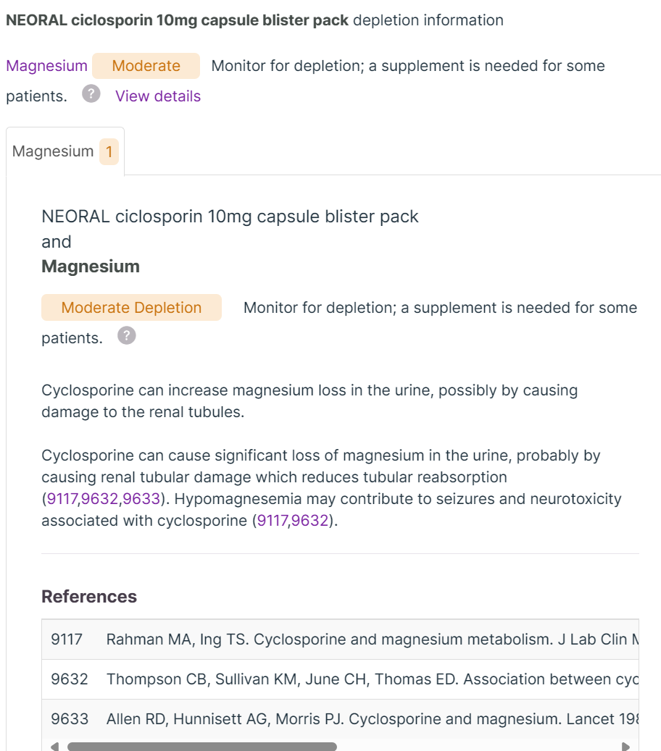

・ネオーラル10mgカプセル(1日1カプセル)：Deplete Mg
Immunosuppressant; Seizure Threshold Lowering Drug
SE: Low energy, hair growth, stomach upset, loss of appetite, diarrhea, headache, sad, flushing face, acne, pain of lower extremities,

TELL DR!!!!!
itching, fever(over 37), unusual bleeding, SOB, Jaundice, tiredness, lack ofenergy, loss of appetite, nausea
and vomiting, pain in the abdomen

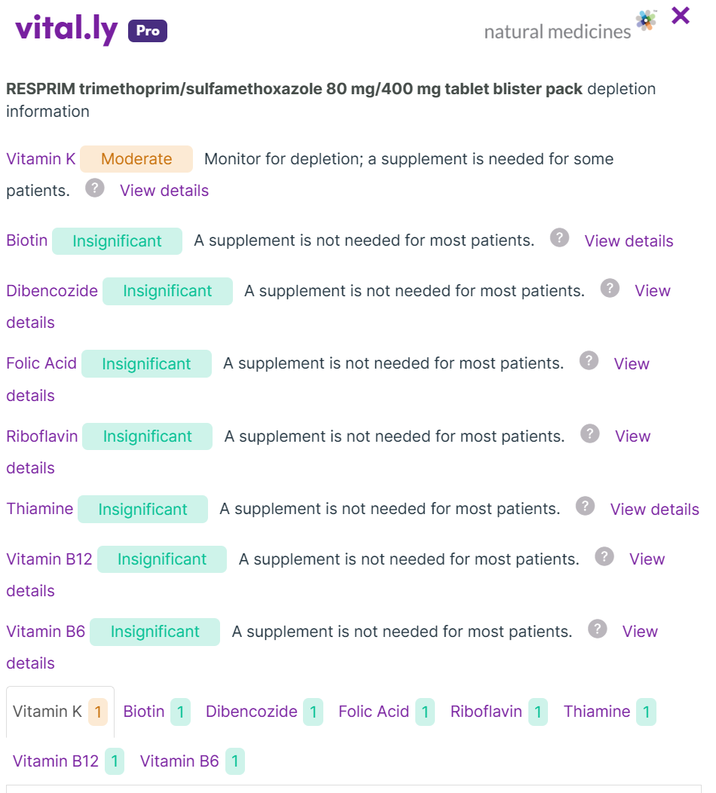
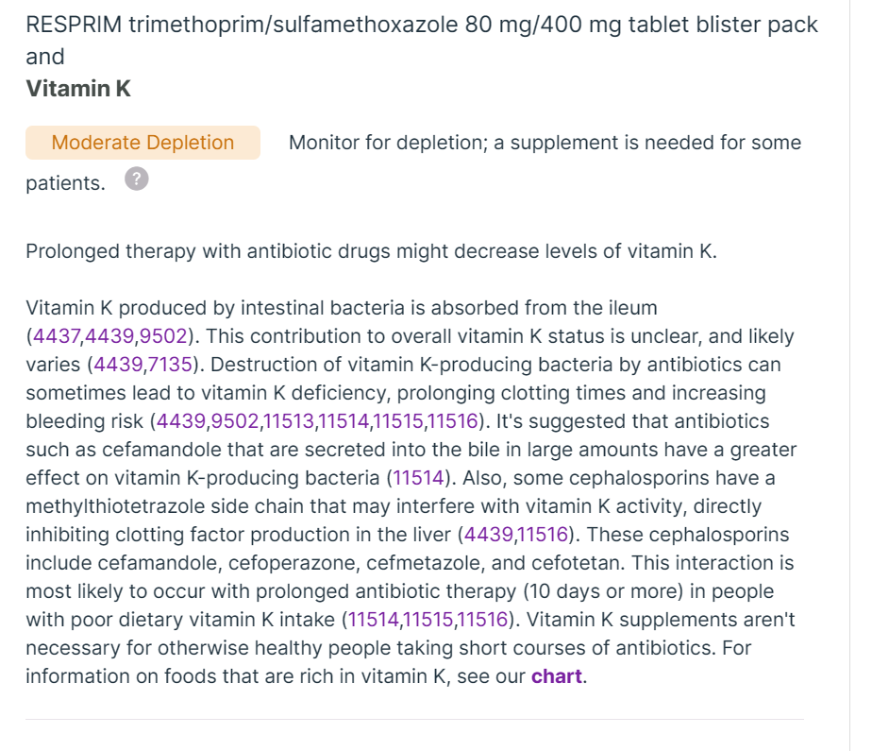
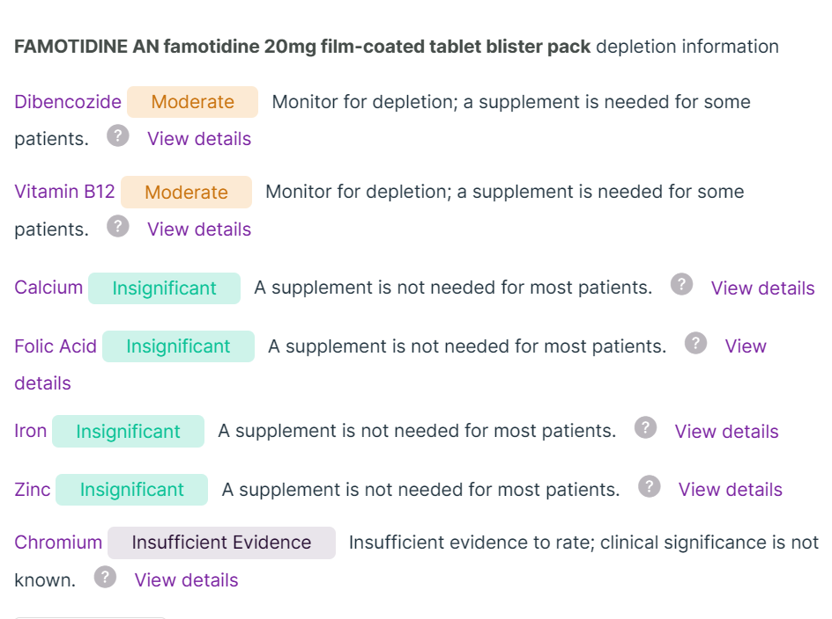
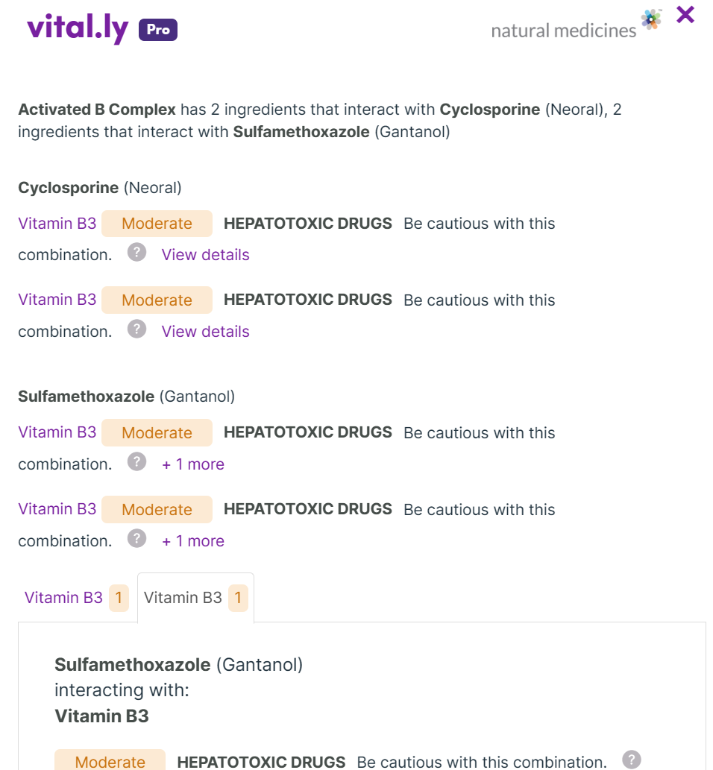
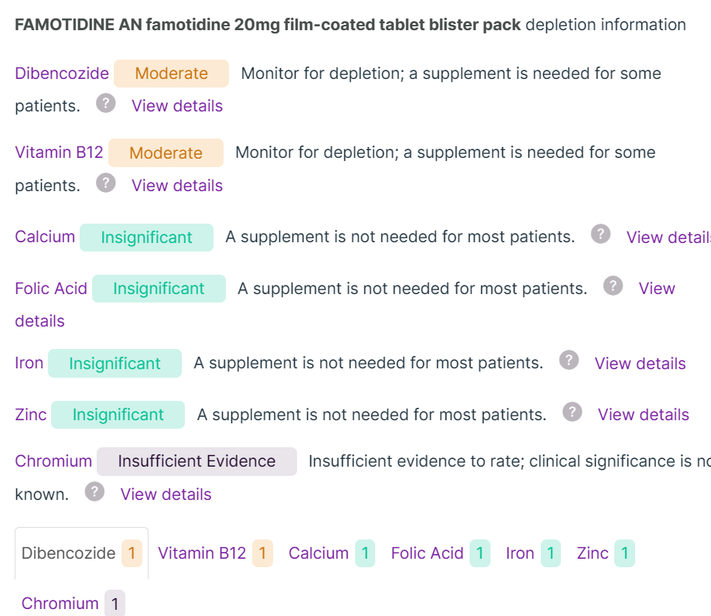

Interactions , vit B3,
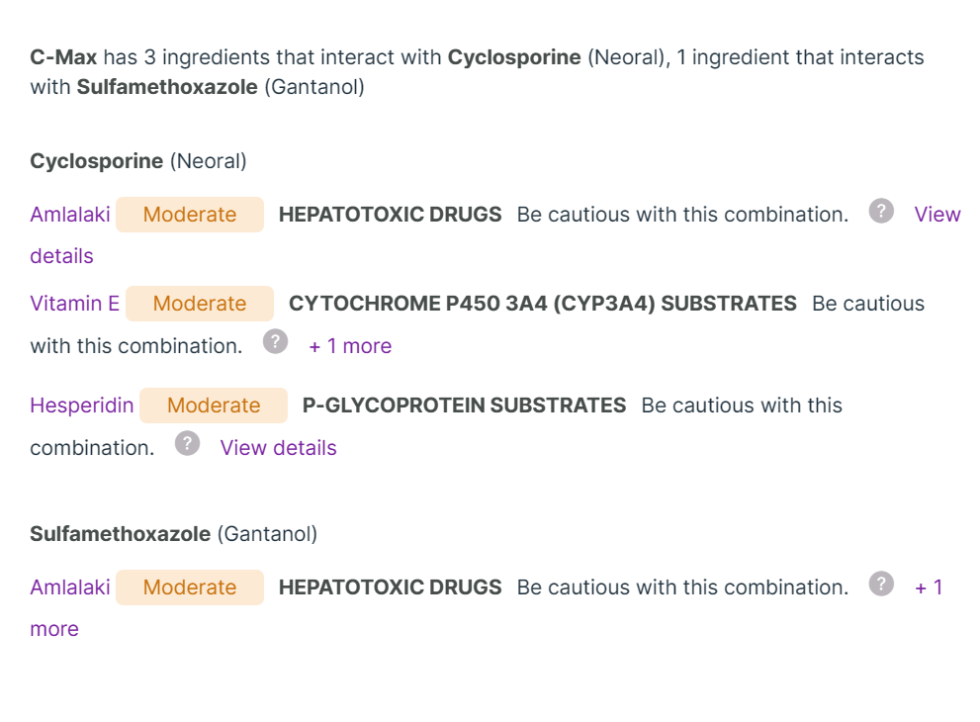
No interaction with Vit B12、B9, CoQ１０、omega3, Vit D(minor)
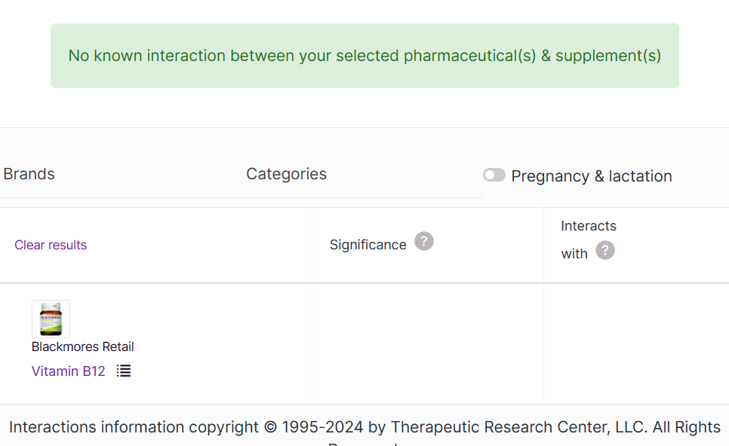
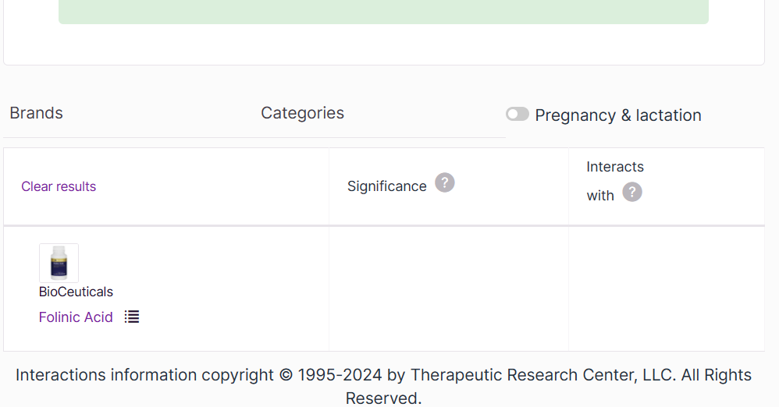
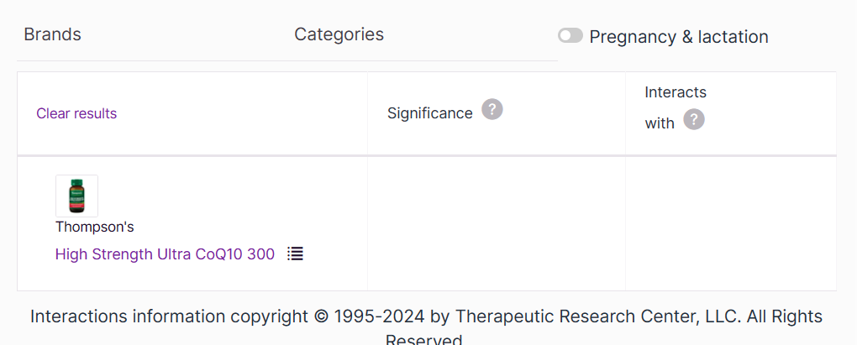
・約5年前〜(入院中の2022年6月〜11月は除く)総合体力研究所、ビタミンC(アスコルビン酸)1日約4,000mg(1回1,000mgずつ)
＊お腹の調子確認！！！！！！

下記全て臍帯血移植後の2022年10月頃〜
・ネオーラル10mgカプセル(1日1カプセル)：Deplete Mg, Cyclosporine can increase magnesium loss in the urine, possibly by causing damage to the renal tubules.
Immunosuppressant; Seizure Threshold Lowering Drug
SE: Low energy, hair growth, stomach upset, loss of appetite, diarrhea, headache, sad, flushing face, acne, pain of lower extremities,

TELL DR!!!!!
itching, fever(over 37), unusual bleeding, SOB, Jaundice, tiredness, lack ofenergy, loss of appetite, nausea
and vomiting, pain in the abdomen

・アシクロビル錠200mg「サワイ」(1日1錠)
Antiviral; Seizure Threshold Lowering Drug
SE: Nausea, Vomiting , Headache, SOB, dizziness, sleep disturbance, pain in legs and joints, Diarrhea, constipation, ***DO of eyes and liver

・ダイフェン配合錠(月水金に1日1錠):Sulfonamide Antibiotic
Deplete: Vit K (M), (I)Biotin, Vit 12, 9, 2, 1, 6
SE: gut symptoms, nausea, Vaginal thrush, Jaundice, diarrhoea, SOB, renal stone, allergic reaction, loss of appetite, sleepless,

・ジェニナック錠200mg(1日2錠): antiviral
No info but most of antibiotics can deplete Vit Bs and K
Photosensitivity (extreme sensitivity to ultraviolet (UV) rays from the sun and other light sources)
Abnormal liver functioning.
Convulsions.
Irregular heartbeat.
Diarrhea.
Nausea.
Abdominal pain.
Headache.

・ガスターD錠20mg(1日1錠: Acid-Inhibiting Drug; H2 Blocker: PPI
M) Vit B12,
I) Ca, Folic acid, iron, zinc

・ミヤBMI(1日3錠): 整腸剤

・ベザフィブラートSR錠200mg「サワイ」(1日1錠)：Acid-Inhibiting Drug; H2 Blocker
Depletions are same as PPI

・ウルソデオキシコール酸錠100mg「トーワ」(1日6錠)
Ursodeoxycholic acid is a bile acid, which may
have a protective effect on the liver by reducing the absorption of other potentially toxic
bile salts.

