プラケニル200 二錠と一錠を交互に。
HYDROXYCHLOROQUINE- class of drugs called antimalarials and is also an antirheumatic drug
The primary mechanism by which hydroxychloroquine modulates systemic lupus erythematosus is by suppressing activation of Toll-like receptors, which exist on the surface of endosomes and play a significant role in the innate immune response and in autoimmune disease.
Lupus Erythematosus
In mild systemic and discoid cases, anti-malarials are the drugs of choice. The dose of hydroxychloroquine depends on the severity of the disease and the patient’s response to treatment. For adults, an initial dose of 400–800 mg daily is recommended. This level can be maintained for several weeks and then reduced to a maintenance dose of 200–400 mg daily
Gastrointestinal Disorders Very Common: Common: abdominal pain, nausea. diarrhoea, vomiting.
Mechanism of Action Hydroxychloroquine is an anti-malarial. It also exerts a beneficial effect in mild systemic and discoid lupus erythematosus and rheumatoid arthritis. The precise mechanism of action is not known.
プレドニゾロン1mm 三錠を2日に一回。
Prednisolonne- Steroid
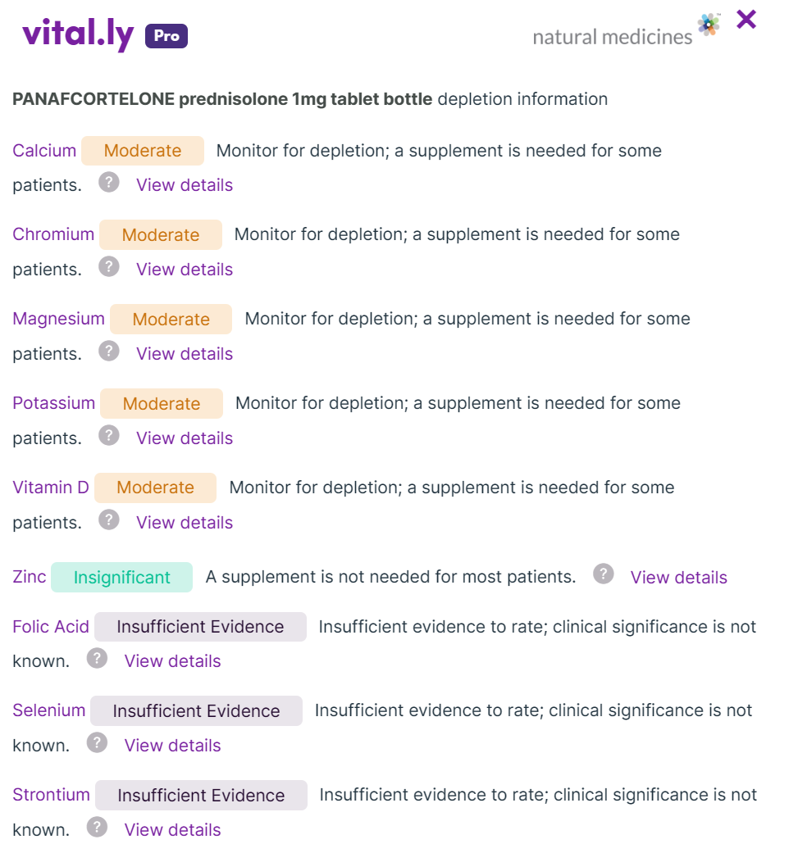
Mechanisms include decreased absorption and increased excretion of calcium, reduction in sex hormones, and inhibition of bone formation. Advise adults taking prednisone 7.5 mg/day (or equivalent doses of other corticosteroids) for six months or longer to maintain a daily calcium intake of 1500 mg/day. They may also need a vitamin D supplement (e.g., 800 IU/da
Corticosteroids increase chromium excretion and can lower chromium levels.corticosteroid-induced hyperglycemia
Chronic use of corticosteroids increases the amount of magnesium excreted in the urine. This is thought to be due to catabolism of bone, releasing magnesium and increasing the amount available for excretion
Corticosteroids might reduce blood levels of vitamin D.
Side effect
• mood changes
increased appetite (which may result in weight gain)
• stomach bloating or irritation • diarrhoea or constipation.
extra hair growth
trouble sleeping.
severe stomach or intestinal pain

エルデカルシトール 一錠
Vit D Analogue
マーベロン(低用量ピル): Marvelon 28
Oral Contraceptive
