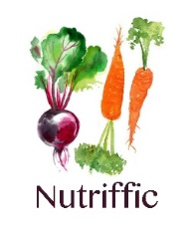
Courtney Harrison - Nutrition Plan
Oct 2019

Good nutrition is where health starts

Short term goals
- Identify foods/things that trigger emotional outburst – keep a diet diary
Long term goals
- Reduce sensory excitations and explosive reactions
- Reduce vaginal irritation
- Improve gut health, bowel transit time
Key dietary inclusions
- Bone broth to heal gut (Nutra-Organics Beef Bone Broth, Organic Garden Herb, or others from health food store) add to soups, as stock etc
- Look for foods and recipes that have high levels of zinc, magnesium and B6 (*see below list)
- Increase vegetables, include as many colour as you can – greens, purples, red, yellows and orange to increase anti-oxidants
- 1-1.5L purified water
- Fibre (RDA Children 10g/day + 1g for every year of age = 15g/day for Courtney).
  - Soluble fibre – Found in fruit and veg, some cereals (oats and barley), psyllium, linseed, slippery elm, legumes (dried peas, beans and lentils)
  - Insoluble fibre/roughage – Found in wholegain foods, skins of fruits and veg, nuts and rice bran. Helps prevent constipation by producing bulky stools and speeding bowel transit time.
  - Resistant starch – found in whole grains, cold cooked potatoes, lentils, firm bananas. Is fermented in the gut and results in beneficial effects on the bowel and cholesterol.
Tips to increase fibre intake
- Replace processed cereals with wholegrain, linseeds, psyllium or nuts
- Add dried peas, beans and lentils to soups, casseroles, salads
- Switch to wholemeal breads, brown rice and wholemeal flours
- Eat raw nuts
- Hummus and carrot/cucumber sticks instead of crackers and cheese
- Eat whole fruit w skin, NO fruit juice
- 2/3 of plate should be plant and protein
- Add 1 extra veg to eve meal
- Avoid excessive meat, animal products, fatty foods, fast foods and sugar.

Shopping Tips
Pantry Staples (#see handout)
Food Labelling – mastering food labels can be a game changer. General rule of thumb, if there are more than 5 or 6 ingredients then you should consider putting it back. If there’s an E in front of a number think twice. Some additives are more harmful than other (*see Resources). The closer to natural you can get the better.
All ingredients in a food product must be listed from largest to smallest by weight. You can use this to spot foods that might be high in saturated fat, added salt or added sugars because these ingredients are listed in the top three. So, if sugar is the first listed ingredient then you’re in trouble, put it back. If for example the ingredient list says “Wholegrain Oats 87%, nuts (almonds 5%, hazelnuts 2%, pecans 1%), seeds 5% (linseeds pepitas)” (** Carman’s porridge sachets).…Awesome! It makes the trolley
Also, look out for other words on the ingredients list that flag ingredients high in saturated fat, added salt or added sugars. Before your next shop go to the pantry and look at all the items you have…identify suspicious ones…and make a conscious effort not to re-buy, or to look for healthy alternatives. The first couple of shops will take more time than usual, but you’ll soon know exactly what to reach for next time.
It’s time to rid the pantry of unhealthy choices.

Foods to include | Foods to avoid
- Zinc (RDA 5mg/day, Upr Limit (UL)supplemental 12mg/day) – shellfish (oysters, crab), beef and other red meats are rich sources. Nuts (cashew, almonds, peanuts) and legumes (beans, chickpeas, baked beans) are good plant sources. Eggs, turkey (dark meat, cooked), pork.  - B6 (RDA 0.6mg.day, UL 40mg/day) – Fortified cereal, potato, chicken (light meat), salmon (wild), banana, turkey (no skin cooked) spinach, hazelnuts, fruit (not citrus)  - Magnesium (RDA 130mg/day, UL 110mg/day) – calming the nervous system – Oat bran, brown rice, dark leafy greens/spinach, nuts, seeds, fish, beans, avos, plain yoghurt, banana, dark choccie  - Fibre – to bulk stool, improve bowel transit time and increase nutrient absorption  - Increase coloured veggie intake instead | - Added sugar, if sugar first listed on ingredients list put it back.  - Eliminate food colouring, additives.  - Excessive fruit (1-2 pieces/day is ok). Berries are a good choice, they’re rich in antioxidants and fibre while lower in natural sugars.

Menu Plan
Aim to eat protein with every meal. Protein and fresh vegetables first to the plate, carbs last to the plate. Eat a rainbow.
Sample Menu
 | Day 1 | Day 2 | Day 3 | Day 4 | Day 5 | Day 6 | Day 7
Brekkie | Scrambled egg on wholegrain avo toast | Chia pudding, add flaxseed oil | Blueberry banana smoothie | Oat and Raspberry Brekkie slice | Veggie frittata w goats cheese | Almond Pancakes | Oat porridge w berries, crushed nuts/LSA and 1 tbsp flaxseed oil.
Lunch | Salmon and cucumber on wholemeal bread | Yum yoghurt Bowl | Pumpkin soup w wholegrain toy soldiers | Grilled chicken and veggie wrap | Peanut butter on Psyllium crackers with veggie sticks on side | Pesto dip with veggies, paleo bread toasted | Grilled Salmon and veggies
Dinner | Chilli Con Carne w brown rice or tacos | Super Simple Veggie curry | Asian chicken cakes | Green Minestrone Soup | Chickpea and spinach curry | Easy Delish Chicken Satay | Steak and Mushroom sauce
Snack | Psyllium crackers with any nut spread | Fresh veggie sticks (snowpeas, carrots, cucumber, with spinach or hommus pesto, guacamole | Pear, nuts, seed mix (pepitas, sunflower, linseeds), coconut shavings, cherry tomatoes, cheese sticks | Celery and nut butter. | Yoghurt with berries, seeds and crushed nuts | Kale chips, homemade bliss ball | Raspberry and oat banana brekkie bar
Sneaky Options @Woolies/health food section, there’s a lot to choose from. Try one or two new healthy options each time you shop.
- Try Olinas Bakehouse (seeded crackers, yum with butter or nut spread, is high in fibre),
- Tasti (Smooshed Wholefood Balls),
- Carmens (porridge sachets),
- Australia’s Own unsweetened almond milk,
- NoSugar chocolate, quinoa porridge sachets.
- Try Paleo Bread and some of the Brookfarm Nut Granolas from Harris Farm
- Organic Alter Eco Coconut Clusters from Harris Farm, as a treat
- Gluten free Wheetbix

Lifestyle
Courtney enjoys a range of activities. Continued physical exercise will cause a release of endorphins naturally in the body and will assist with mood elevation and control and down regulate the central nervous system stress.
Recommended tests/information
- Pyrrole levels (urine sample)
- Food sensitivity panel?
Therapeutic Micro Nutrients and Pro-biotics
- Spectrumceuticals Probiosis 5 - multi strain pro-biotic to rebuild gut microbiome following several courses of Abs)
- Pending Pyrrole testing - Spectumceuticals MagnEZinc - Mood/neurotransmitter and immune system support

Recipes

Almond Pancakes
 | Ingredients | Method
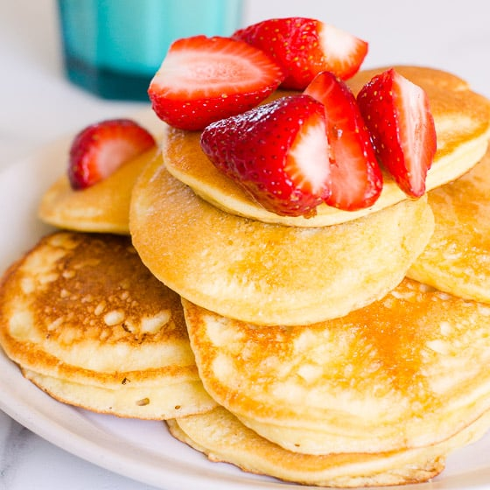 | 2 tbsp almond meal  2 tbsp coconut flour  1 organic or free-range egg  1 organic or free-range egg white  ¼ cup sparkling water  Pinch salt  Coconut oil for cooking | - Mix all ingredients in a bowl until no lumps  - Use ¼ measure to spoon mixture into pan oiled w/ coconut oil  - Look for bubbling/browning of the edges b4 flipping  - Makes 4 x small pancakes

Banana Blueberry smoothie
 | Ingredients | Method
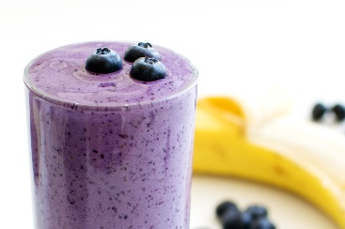 | 200g coconut or unsweetened almond milk  ¼ cup frozen or fresh blueberries  1 fresh or frozen small banana  ¼ cup fresh spinach leaves  1 tbsp ground flaxseed or flaxseed oil  ¼ tsp vanilla extract | Blend until smooth

Coconut Chia pudding Brekkie Bowl
 | Ingredients | Method
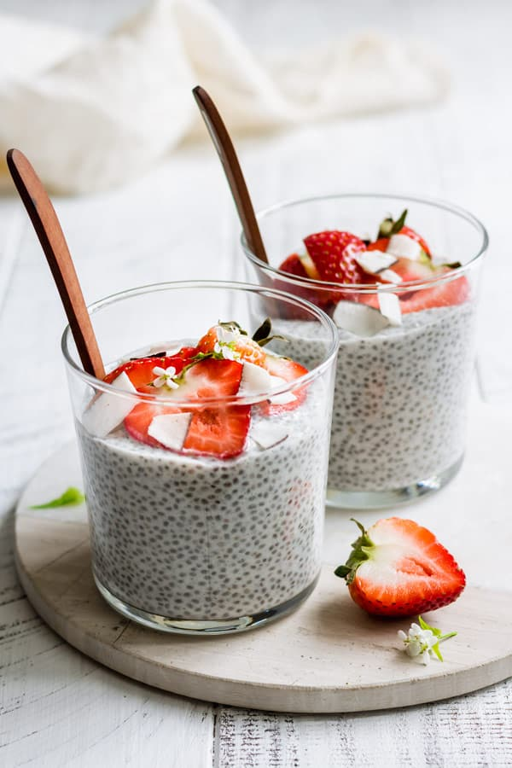 | 1/4 cup chia seeds  2 tbsp shredded unsweetened coconut  1 ¼ coconut milk  1 tsp vanilla extract  2 tbsp maple syrup | Mix all the ingredients together in a bowl.  Let sit on the counter for 10 minutes, giving it a stir every 2-3 minutes.  Cover and place in the fridge to firm up for 1-2 hours.  Remove and enjoy.  Top this chia pudding off with some strawberries/berries and coconut chips.  TIP: Store this chia pudding in the fridge for up to a week in an air tight container
Pumpkin Soup
 | Ingredients | Method
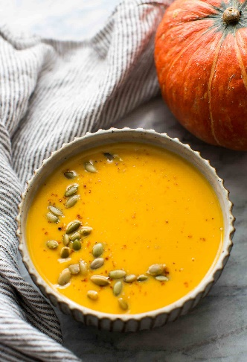 | 500g pumpkin, skinned and cubed  2 cups chicken stock  1tbsp ginger  Pepitas  S&P | Place ingredients in crock pot and mix  Set on low for 1-2 hours until pumpkin soft  Puree with blender  Sprinkle w/pepitas  Enjoy dipping with wholegrain ‘toy soldiers’

Psyllium Seed Crackers
 | Ingredients | Method
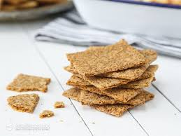 | 250g Mixed Seeds (Pumpkin, Sunﬂower, Linseeds)  2 TBS Psyllium Husks  1/2 tsp Crushed Garlic  1/4 tsp Sea Salt  1/4 tsp Paprika  1/4 tsp Mixed Herbs  Fresh Black Pepper  500ml water | Preheat your oven to 160º C. Lightly oil your ﬂat baking tray with some coconut oil  Add the psyllium husks to a mixing bowl, and gradually add the water until you get a thick, slightly gooey mixture. Let sit for 20 mins.  Add the remaining ingredients and mix thoroughly.  Spread the mixture out as even and thin as possible, without it separating.  Bake for about 30 mins  Take the tray out, break the cracker sheet into portions, and pop back into the oven for a further 20-30 mins or so. Keep popping them back in until they are crisp rather than bendy. You can also leave them in a warm oven overnight to further dehydrate.  Top them with avocado, tomato and Fetta or Pesto.  TIP: If you end up with bits that aren’t big enough for crackers, they make a great addition on top of a salad.

Yum Yoghurt Bowl
 | Ingredients | Method
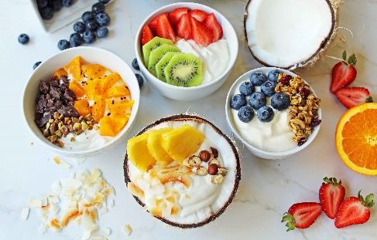 | 1/2 cup Full fat Greek yoghurt or Coyo  1/4 cup frozen or fresh blueberries 1/4 cup mixed pepitas and sunﬂower seeds  1/4 cup chopped almonds  Sprinkle of cinnamon | Yoghurt first, then layer other ingredients on top according to taste.  Sprinkle cinnamon

Easy CCC (Chilli Con Carne)
 | Ingredients | Method
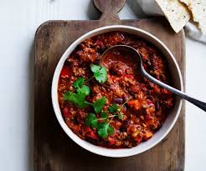 | 6 tsp olive oil  2 med sized onions, diced  2 cloves garlic  750g minced meat  250g canned tom  1/3 cup tomato puree  1 bay leaf  1 tsp dried oregano  2 tsp ground cumin  Chilli powder or cayenne pepper  2 cups beef stock  800g kidney beans  S&P | In large heavy saucepan, heat the oil over moderate heat. Add onions & garlic and fry 5-6 mins  Add meat and brown, stirring from time to time to break lumps  Add remaining ingredients & bring to boil. Reduce heat to simmer 1-1.5 hours.  Serve with rice or tacos, sour cream and grated cheddar cheese  Easy to make the night before.

Super Simple Veggie Curry (serves 4)
 | Ingredients | Method
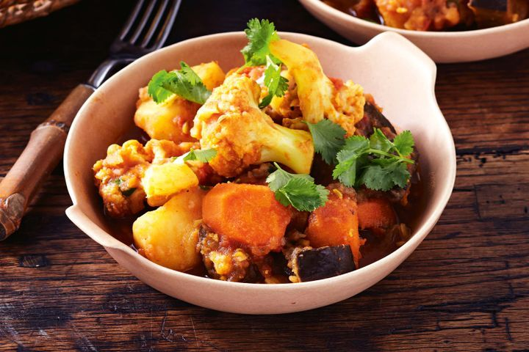 | Sweet potato, broccoli, cauliﬂower, Spinach, Red onion  Red curry paste  1 can coconut cream  1 tsp Tumeric powder  Keﬁr lime leaf  Optional: 150 grams of chicken per person (to make it non-veg)  Add any above ground vegetables that you like | If adding chicken, gently fry in coconut oil & set aside.  Saute red onion in a pan  Add Red curry paste and 1 can of coconut cream, 1 tsp Tumeric and kefﬁr lime leaf.  Add the sweet potato and simmer for 10 mins  Add the cauliﬂower and broccoli and simmer for 5 mins  Add the spinach and simmer.  Optional: Add the chicken and simmer until hot, before serving on cauliﬂower or brown rice

Chickpea & spinach curry (serves 4)
 | Ingredients | Method
 | 200g dried chickpeas (or 1 can chickpeas)  2 tbsp sunflower oil  2 onions, thinly sliced  2 tsp ground coriander  2 tsp ground cumin  1 tsp chilli powder  ½ teaspoon ground turmeric  1 tbsp med curry powder  400g canned chopped tomatoes  1 tsp soft brown sugar  2 tbsp chopped mint leaves  100g baby leaf spinach  Salt  Natural Greek Yoghurt  100ml water | (If Using dried) Soak chickpeas in cold water overnight, Drain, rinse and place in saucepan. Cover with water and bring to boil. Reduce heat and simmer 45 mins until just tender. Drain and set aside.  Heat oil in wok, add onions and cook over low heat 15 mins until lightly golden. Add coriander, cumin, chilli powder, turmeric and curry powder and stir-fry 1-2 mins  Add tomatoes, sugar, water and bring to boil. Cover, reduce heat and simmer gently 15 mins.  Add chickpeas, season well and cook gently 8-10 mins. Stir in chopped mint.  To serve, divide spinach leaves between 4 shallow bowls and top with chickpea mixture. Drizzle over yoghurt if desired.  Serve

Supergreen minestrone with white beans (Donna Hay) serves 4
 | Ingredients | Method
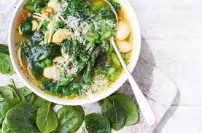 | 1tbsp extra virgin olive oil  2 cloves garlic, thinly sliced  1 leek, white only, thinly sliced  Sea salt & black pepper  1 Litre veg stock  500ml water  10 brussels sprouts, trimmed and thinly sliced  400g can white cannellini beans, rinsed and drained  2 zucchini, spiralised or thinly sliced using mandoline, julienne peeler  80g baby kale leaves  Basil leaves, chilli flakes, finely grated parmesan | Heat oil in med saucepan over med heat. Add the garlic, leek, S&P and cook, stirring 4-6 mins until light golden and soft.  Add stock and water, increase heat to high, bring to boil and cook for 5 mins. Add the brussels sprouts, beans, zucchini and kale and cook 2 mins or until just softened.  Serve w basil, chill, parmesan and baguette.  *substitute other greens for brussels sprouts, if desired.

Asian chicken cakes (*substitute pork or beef) (serves 4)
 | Ingredients | Method
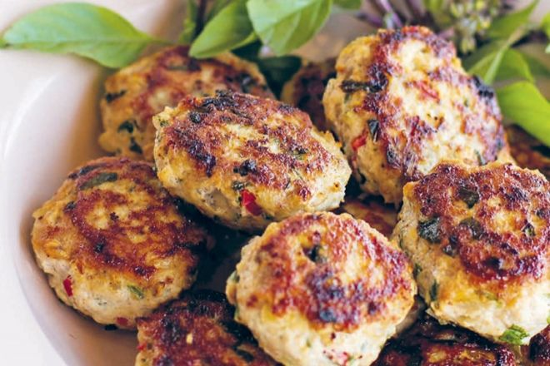 | 800g chicken or turkey mince  2 eggs  Chilli flakes  2 garlic  2 tbsp fresh coriander, diced  1 tbsp thai basil leaves, diced  3 tbsp green onion, diced  Thumb-sized ginger, grated  2 tbsp fish sauce  1 tsp sesame oil  Zest 1 lime  2 tbsp lime juice  2 tbsp coconut oil | Combine all ingredients and use your hands to mash incorporate. Roll into golf ball sized rounds and flatten  Heat ghee or coconut oil to sizzling and cook cakes on medium 5-7 mins each side  Serve w cucumern, thai basil

Easy delish Chicken Satay (adapted from Basics to Brilliance kids by Donna Hay) (Serves 4)
 | Ingredients | Method
 | 1/2 cup (125ml) coconut cream  1 cup (140g) roasted unsalted nuts (cashew works well)  1 tsp grated ginger  1 Tbsp Tamari sauce  1 pinch dried chilli ﬂakes (optional) 4 x 200g chicken thigh ﬁllets or breast ﬁllets | Place coconut cream, nuts, ginger, tamari and chilli in a blender and combine until the nuts are ﬁnely chopped.  Cut chicken into 2cm thick strips, add to the nut mixture, toss and refrigerate for at least one hour or overnight to marinate.  Thread the chicken onto skewers (soak wooden skewers for 10 mins in water ﬁrst to avoid burning)  Lay skewers on a baking tray, spoon over remaining marinade and grill on high in the over for approx. 5 mins or until golden on top.  Turn the chicken and grill for another 5 mins until golden and cooked through.  Serve with lime wedges and salad.

Steak with creamy mushroom sauce (serves 1 plus sauce to freeze)
 | Ingredients | Method
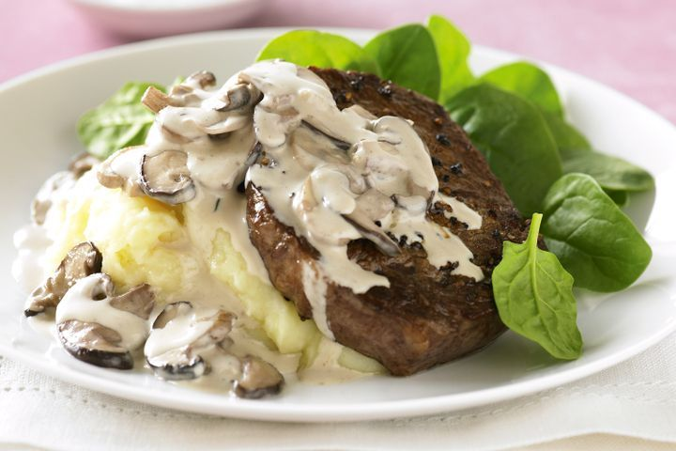 | 120g Grass-fed steak  1 Tbsp EV Olive oil  2 Tbsp butter 1/4 cup shallots  2 cloves of minced garlic  450g mushrooms  1tsp mixed herbs  1 cup chicken stock  1 cup double cream  salt & pepper | Season your steak of choice in some salt and pepper.  Heat a heavy bottomed pan on high then add oil and butter sear for 3 or 4 minutes on each side until browned.  Remove the steak and set aside.  Keeping the pan on high, add shallots (or onion), mushrooms, garlic and seasoning before sautéing for a couple of minutes to soften.  Add the stock and simmer for 5 minutes to reduce the liquid. Stir through the cream.  Add the steak back into the pan with the sauce and cook for a couple of minutes (to your liking)  Left over sauce can be kept in an airtight container in the fridge for 4 days or frozen for 2 months. Can be used to top steak, chicken, pork or ﬁsh.

Grilled Salmon
 | Ingredients | Method
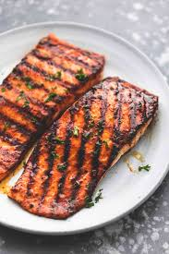 | Approx 150g salmon ﬁllet per person | Cover and grill over medium heat for about 5 minutes per side (maybe a few more minutes, depending on the thickness of your ﬁsh).  The salmon is done when it ﬂakes easily with a fork.

Spinach Pesto
 | Ingredients | Method
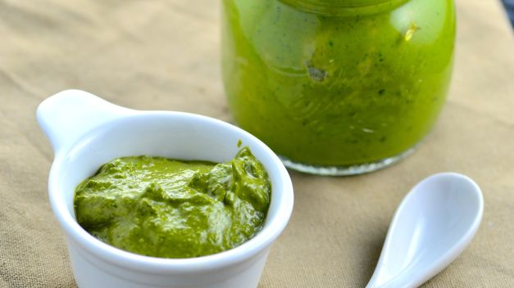 | 2 cups fresh spinach leaves, well-washed and stemmed  1⁄2 cup fresh parsley, preferably Italian flat leaf  1⁄2 cup walnuts or 1/2 cup pine nuts, toasted  1⁄4 cup parmesan cheese, freshly grated, not canned  3 garlic cloves  2 tablespoons extra virgin olive oil  1⁄4 teaspoon sea salt  1⁄8 teaspoon fresh ground black pepper | Place all ingredients into food processor and process to a fine paste.  Taste and adjust seasonings and transfer to a glass container and top with a thin coat of olive oil to prevent the top of the pesto from discolouring.  Keeps for weeks in the refrigerator.

Cacao Bliss Balls (nut free)
 | Ingredients | Method
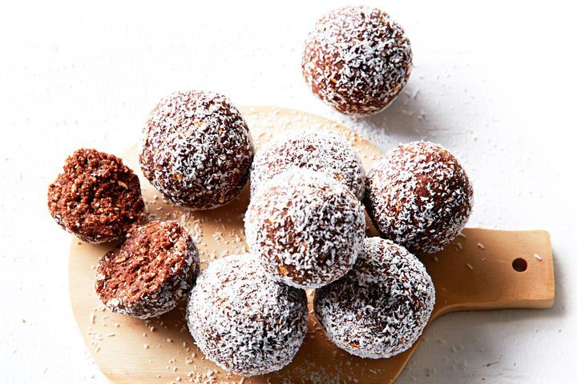 | 150g pumpkin seeds  150g pitted dates  50g cacao powder  30g coconut oil  ¼ tsp vanilla essence  2 pinches Himalayan Salt | Place pumpkin seeds into high speed blender and mill until like ‘meal’  Place dates into mixing bowl and chop until past-like consistency  Add milled pumpkin seeds and all remaining ingredient and mix 30 seconds.  Roll into balls or press into slice tine and either leave plain or roll in coconut, crushed almonds or cacao and refrigerate

Kale chips
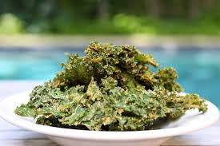 | 1 large bundle curly green or purple kale  1-2 Tbsp melted coconut or avocado oil  Seasonings of choice (i.e. pinch sea salt, 1 tsp cumin powder, 1 tsp chili powder, 1 tsp curry powder, 1 Tbsp nutritional yeast, etc) | Preheat oven to (100 C). Use convection bake if you have it to speed cooking time and help chips crisp up even more.  Rinse and thoroughly dry kale, then tear into small pieces and discard any large stems.  Add to a large mixing bowl and drizzle with oil and seasonings of choice. Toss thoroughly to combine, using hands to distribute the oil and seasonings evenly.  Spread the kale over 2 large baking sheets (use fewer or more if adjusting batch size), ensuring the kale touches as little as possible to help them crisp while baking.  Bake for 15 minutes, then turn the pans around and lightly toss/stir kale to ensure even baking. Bake for 5-10 minutes more, or until kale is crispy and very slight golden brown. Watch closely as it can burn easily.  Remove from oven and let cool slightly - chips will crisp up even more once out of the oven.  Enjoy immediately! Best when fresh. Store leftovers covered at room temperature for 2-3 days.

Raspberry and oat banana breakfast bars (Donna Hay) – can also use for snacks
 | Ingredients | Method
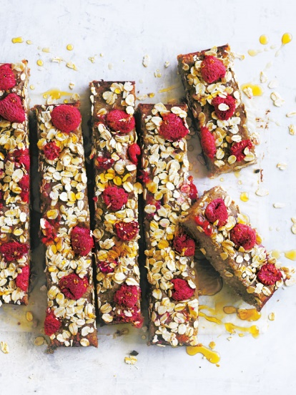 | 225g raw cashews  120g desiccated coconut  3 med ripe bananas (300g), peeled and chopped  10 fresh dates (200g), pitted  2 tsp vanilla extract  ½ tsp bicarb soda (baking soda)  125g fresh raspberries  ½ cup rolled oats | Preheat oven 180C. Line and lightly grease slice tin w baking paper  Place cashews, coconut, banana, dates, vanilla, bicarb soda in food processor and process, spraping down sides occasionally until smooth.  Fold half raspberries and half oats into the mixture, spoon into tin and smooth the top w a knife  Gently press remaining oats and raspberries into the top and cook for 25 mins until top is dry and golden.  Set aside for 10 mins to cool, then refrigerate until cold. Cut into slices

Resources
Food Additives Guide, Stefan Mager
The Healthy Chef App, Teresa Cutter
https://www.eatforhealth.gov.au/eating-well/how-understand-food-labels
https://choosingchia.com/coconut-chia-pudding/
www.minimalistbaker.com

Cookbooks
Supercharged Food for Kids, Lee Holmes
Eat Drink Paleo, Irena Macri
CSIRO Healthy Gut Diet
200 Curries, Sunil Vijayakar

