
Kinesiology Coaching for Sally Snow

Session 1 – 04th July 2024

Main Concerns
- Wanting to be in a relationship with the ‘right’ partner (doesn’t want to do life alone)
- Would like to build a successful career (away from teaching in its current format). Loves teaching and inspiring children but doesn’t enjoy teaching concepts in a structured or rigid format).
- Feels there is a history of quitting things and would like to find things that light you up and sustain you.
- Would like to create financial freedom
- Would like to explore your creative and imaginative side and integrate this into a career

Ideas Generated
- Plant nursery with fairy garden, maze, magic space
- Large acreage that is a day trip for families. Has café, animal feeding/riding, creek (feed turtles), private gatherings, bungalows on creek and a flower garden.
- Stories (books) that evolve into movie/stage theatre production.
- Characters take the lead role in opening new avenues for new activities/ adventures/ theme park/ experiences.
- Fairy café hosting kids’ parties
- Storybook series with talking animals
- A character that resonates and inspires with people (memorable and significant)

Affirmations
- I let go of all sabotages and express myself with Ease
- The more integrated I am, the more happy I become
- I let go of all shame and embrace happiness
- I am a growing and evolving soul
- I am filled with the excitement and enthusiasm of change
- I can ask for what I want even if I can’t fathom how it will happen

Animal Totem: Deer
The deer is a sensitive, highly intuitive spirit guide. It strikes a balance between confidence and success and gentleness and grace. The deer’s healing wisdom relates to the path of the open heart, gentle strength, unconditional love and compassion. The deer represents that it is time to be compassionate towards yourself and others. Deer as a totem animal belongs to those who shine the light so others may find their way home.

Crystal: Chrysoprase: Fearless Movement

Mentally Chrysoprase encourages non-judgmental attitudes. It bolsters clarity of thought and creativity by attracting abundance and success in new ventures and promotes fidelity within business. It is good for anybody going through some period of transition or development.

Emotionally, chrysoprase is said to help heal a broken heart by providing a gentle boost to your self-esteem, equalizing emotional balance and fostering acceptance of change and tolerance from others. It encourages compassion, self-development, personality and overall happiness.

Flower Essence: Pretty Face

“Beauty is not in the face; beauty is a light in the heart,” wrote Kahlil Gibran. Such is the message of the Pretty Face flower essence: Beauty is an inner radiance of the soul, which can shine through the face we present to the world. This is a radically healing message, especially in a society that spends hundreds of billions of dollars on cosmetic products concerned only with surface appearance.

Affirmations and inspirational words related to Pretty Face:
- I accept all parts of myself
- Light shines through darkness and pain
- My whole self is my beautiful self
- I am this Shining Star

Chakra Card: Forgiveness

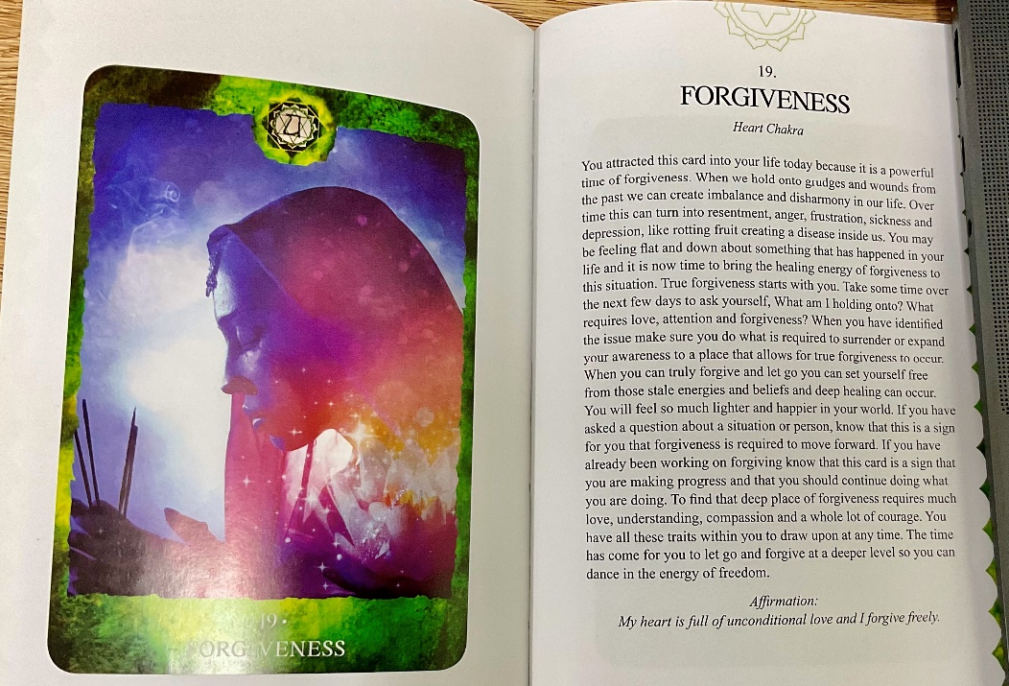

Balance
- Worked on deeper self-belief and self-esteem
- Afraid of the Yang parts of self (avoidance)
- Stages of creation in formulating goals and intentions
- Motivation indicated an emotional blockage of being frightened to have a go
- Cerebellum we worked on the feedback assessment of plans going into action

Homework
Create 3 characters (we are not looking for perfection or finalisation)

