CASSIE HOWER  HERBALIST  PLANTS + PASSION  cassie@plantsandpassion.com  www.plantsandpassion.com.au  DATE: 17 July 2024  PRESCRIPTION FOR:  Natalie King | 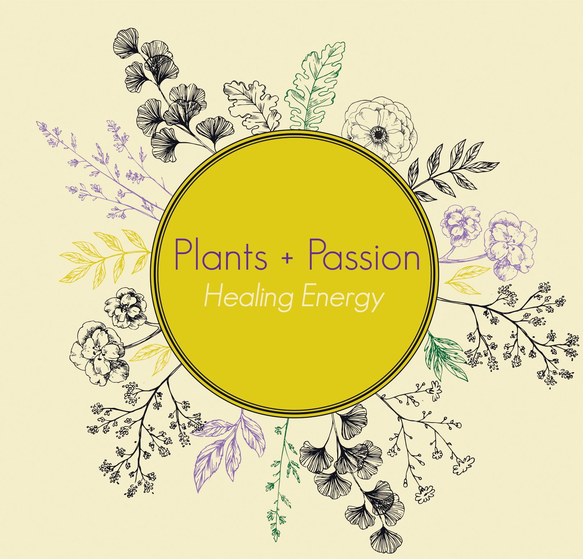
Next appointment:
12pm Thursday 15 August 2024 (Telehealth)

Treatment Aims:

Tonify and support the nervous system
Support energy levels and help adapt the body to stress
Tonify detoxification pathways/liver to improve clarity of skin and eyes

HERBAL BLEND (new bottle)

Lemonbalm – relaxing and restoring yet also uplifting. Restores mood and nerves, stabilises energy, reduces fatigue due to overstimulation and stress, affinity with the heart – courage of heart, supports cognition.

Withania – gentle adaptogen, bringing your energy back in – reduces night time elevations of stress hormones (will improve sleep). Also neuroprotective.

Schisandra – Supports liver, nervous system, adrenals, digestion and female reproductive system – a wonderful allrounder and great female tonic!

Ginger – warming, circulatory stimulant – helps to move the other herbs to where they need to go, a wonderful digestive too

Take 1 dropper full (approximately 1ml) morning and night in 20ml of water

When taking the herbs, take a few moments or longer if you can, to really feel into your body and notice anything that arises for you at those times. It may be sensations, a picture in the mind or some thoughts dropping in. Taking it one step further and journaling anything that arises could be a good way to reflect on what’s going on for you internally in the mind and the heart.

The above herbs are not limited to treating what I have listed above, however I wanted to show you why I chose these particular herbs for you. All herbs and their constituents work in synergy together within a blend to bring harmony and balance where needed.

HERBAL SIMPLES:

Liquorice/Licorice (new bottle) – a beautifully gentle adrenal tonic – can be stimulating so take only in the morning – add 5 drops to your morning herbs – can increase to 10 drops. Licorice is cortisol sparing so helps to maintain energy levels.

Passionflower (on hand)– for increased anxiety and nervous system support during transition and heightened emotions – take 5 drops as needed (up to 10 drops) – upper limit is high with this herb but be aware that you have felt drowsy the next day on higher doses (5ml) – it’s a glcytract so can dose directly onto the tongue

FLOWER ESSENCE (new bottle)

Bottlebrush – for transitions and clearing out the past to move forward into new role from a clearer energetic state – letting go of the past and going with the flow into new experiences

Illawarra Flame Tree – increase confidence and commitment, increased self-approval and self-reliance

Fringed Violet – protection of the aura in transition to new workspace around new people and their energy fields

Hibbertia – addressing guilt in relation to potential move

Take 7 drops under your tongue upon rising in the morning and upon retiring in the evening – you can also add 7 drops to your water bottle to drink across the day

HERBAL TEAS

Nervous system support (on hand):
Oats – nervous system support and nutritive
Nettle – nutritive
Tulsi (Holy Basil) – “Elixir for Life“ - beautiful nervine herb supports the whole being (body, mind, soul, spirit) – an Ayurvedic medicine and lovely to grow in the garden (great for bees and teas)
Hibiscus – adds a beautiful colour and taste, one for the senses

Sleepy tea (new):
Chamomile: sedative and soothing to the digestive tract (a lovely after dinner and pre-bed tipple)
California Poppy: sedative and muscle relaxant, “let the day fall away”
Motherwort: lion hearted mother, relieves stress and anxiety, feels like being wrapped in a big warm hug
Rose petals: beautiful heart medicine – perfect for calming the anxious heart

Preparation of teas:
Add 1-2tsp of the tea to a teapot with strainer and cover with boiling water (240ml-500ml), cover and allow to steep for 5 to 10 minutes. Take 1-2 cups/day

Or prepare as an overnight infusion (Nervous system tea only, sleepy tea will be too bitter):

Take a 1L glass jar with a lid, add 2-4 tsp of tea, cover with boiling water, allow to steep overnight, strain in the morning and consume during the day either cold or rewarmed in a small saucepan on the stovetop. Feel free to add fresh ginger and mint from your garden to this tea and some honey to sweeten if needed.
DIET AND LIFESTYLE:
- Book yourself in for a kahuna massage (at least once a month until you move)
- Put a notebook and pen beside your bed to remove thoughts from your mind as needed overnight
- Visualise and journal living in your new house in Coffs Harbour and what your life is going to look like in 6 months.

