CASSIE HOWER  HERBALIST  PLANTS + PASSION  cassie@plantsandpassion.com  www.plantsandpassion.com.au  DATE: 17 July 2024  NAME: Natalie King  CONSULT: Return Telehealth (short 30 mins) | 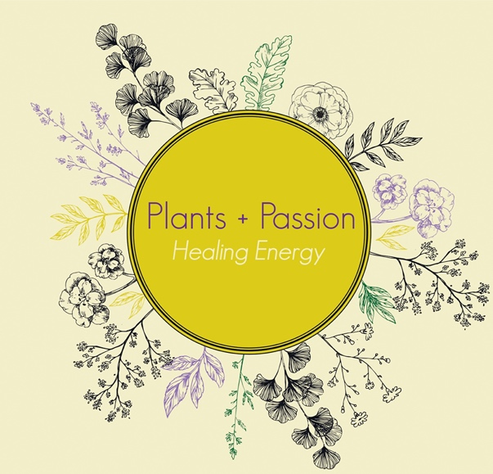

Medications and safety issues:
(pregnancy, lactating, allergies)

Zoloft
Mirena

Presenting complaint:

Boys are enjoying flower essences but she doesn’t feel it’s needed to continue, they’re in a good place
Main load (additional to single mum and work) – coordination of the move
Sleep is not great – mind is in overdrive
Work is great – very supportive and flexible
Mum has already moved to Coffs – extra juggling with boys now but coping okay (just has to plan ahead more)

Licorice – completely out
Herbal blend nearly out
Enough passionflower
Flower essence for Nat, not for the boys
Sleeping tea blend 100g
30ml face oil dropper bottle

Is feeling good about current treatment plan and would like to continue with extra support for improving sleep

Nil dry vagina (as per previous symptom picture two-three consults ago)
Perimenopausal symptoms? Nothing physical, noticing some mood changes:
Frustration from fielding too many questions at the moment but has good boundaries in place and can kindly but firmly speak her mind on this
Comes from the family that needs to talk about everything all of the time (sometimes feels like she needs to lock herself away from this)
Always had to carry the load of her mother
Brother in Coffs will have to share that load now
Greg (ex) has been kind and nice lately (which she feels is guilt on his behalf as that is his patterning with her)

Lifestyle

Stress: Currently has a lot on her plate but feeling like she’s managing it all really well with the things she has in place and the treatment plan we have her on.

Movement: Consistently going to pilates 4 days a week

Energy:

Sleep: broken sleep due to racing mind – sleeping horribly

Diet

Eating really well

Systems
Nothing of not in any other systems.

GIT:

Nervous: see above

Immune/respiratory:

Hepatobiliary:

Integumentary:

Renal/Urinary:

Female repro:

Etc:

