
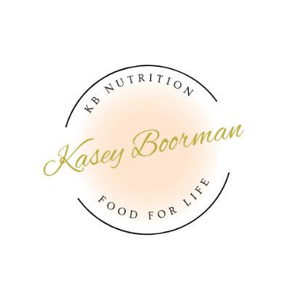
Holistic Health Treatment Plan

Client Name: Claire
Date: 25.7.24
Health Priorities
Weight Loss, digestive health
Secondary: Pre-conception
Health Goals | Time to Achieve:
- Increase Energy Intake (overall food intake) by 3000kJ per day  - Eat 3 small meals and at least 1 snack per day  - Increase fibre to 25g per day  - Increase vegetables from 2 to 3-4 serves per day  - Increase fruit from 0 to 1 serve per day  - Increase wholegrains to 3 serves per day  - Include protein in every meal (chicken, tuna, eggs, beef etc.)  - Include red meat 3 times per week (for iron) | 2 weeks
Strategies
Diet  - Add spinach and mushroom to scrambled eggs (if don’t want eggs at breakfast – yoghurt, muesli at work then 2 boiled eggs as morning snack)  - Make a frittata (8 eggs, spinach/kale, mushroom, tomato, herbs and spices) and cut into 4 serves for lunches.  - Include 1-2 snacks per day (2 x boiled eggs, hummus with capsicum/carrot sticks and wholegrain rice crackers, yoghurt, protein shake, 30g nuts, piece fruit)  - Swap ham to chicken breast at lunch  - Include 1 cup frozen vegetables to tuna and brown rice at lunch time  - Easy lunch option – 3 times vita/wheats or brown rice cakes with cottage cheese, tomato and tuna/salmon  - Swap white bread to wholegrain at lunch  - Include red meat 3 times per week (beef, lamb, mince)  - 100g protein and 2 cups veg at dinner (1 cup to be green vegetables – broccoli, kale, spinach, zucchini, Bok choy. 1 cup can be starchy – sweet potato, pumpkin, corn, potato)  - After dinner options – herbal tea and 2 squares of dark chocolate  Home made brownie mix – keep in freezer (Mt elephant blondie mix) | Lifestyle  - Reformer 2-3 times per week  - Meal prep when possible (boiled eggs, hummus and veg cut up)  - Try meditation, mindfulness or reading to wind down/relax at end of the day  - Continue to complete a food diary for the first week  - Aim for 3 drinks alcohol per week maximum
Referrals/Investigations | Prescriptions
MTHFR gene – read up on it here: https://mthfrsupport.com.au/2018/11/mthfr-and-fertility-complications/  Something to keep in mind for future | Pre-natal vitamin – garden of life once daily  Iron supplement – Biomedica BioHeme 1 x day  Sleep X magnesium – one serve in water prior to bed  Myoinositol/carnitine/magnesium compound – 1 serve before breakfast, 1 serve before lunch for 4 weeks
Barriers to change | Strategies to overcome barriers
Time | Easy meals that can be premade/ made in bulk

Sample Day Menu

Upon waking: ½ lemon squeezed into 250ml warm water

Breakfast: 200g Greek yoghurt, ¼ cup muesli, handful berries (can be frozen). Muesli recommendations:
https://www.woolworths.com.au/shop/productdetails/553342/sunsol-natural-muesli-almond-cashew-macadamia-walnut
https://www.woolworths.com.au/shop/productdetails/336408/morning-sun-apricot-almond-breakfast-cereal
OR overnight oats (see recipe)
OR 2 scrambled eggs on 1 slice wholegrain toast, ¼ avo (add spinach/mushroom/tomato) (frittata?)

Snacks: 2 boiled eggs
OR 30g nuts and piece of fruit if had eggs for breakfast

Lunch: 90g Chicken, ½ tomato, 2 slices cheese, ¼ avocado, ½ cup spinach on 2 slices wholegrain bread
OR 1 tin tuna, ½ cup brown rice, 1 cup frozen veg (add pesto?)
OR leftover dinner
OR make big batch of chicken and vegetable soup (see recipe below)

Snack: ¼ cup hummus, vegetable sticks, 8 wholegrain rice crackers
OR 30g nuts
OR 200g Greek yoghurt

Dinner: 90g Salmon, Veg (including ½ cup broccoli and ½ cup cauliflower, ½ cup other), ½ cup brown rice with 1 tbsp sesame soy dressing

Other dinner options: Taco bowls, steak/fish/chicken and veg, Stir fry chicken – brown rice, vegetables, Roast meat and vegetables (1 cup green veg, 1 cup carrot/pumpkin/sweet potato/potato), slow cooker curry, rissoles and salad/mash and greens, Meat and Veg soups

Meal prep options – buy chicken and salad sandwich on wholegrain bread or wrap
OR take tuna, brown rice, 1 cup veg
OR pre-make – chicken stir-fry (chicken, brown rice/quinoa and veg), frittata, pesto pasta with chicken/tuna and veg (more veg then pasta, little bit of cheese)
Frozen meals – Muscle Chef – Braised beef ragu, Beef stroganoff, peppercorn steak, Peri Peri chicken, Smokey BBQ chicken, Garlic chicken, Coconut turmeric chicken, Thai peanut chicken stir-fry,

Post Dinner – 2 squares dark chocolate and herbal tea, pre-made brownie, yoghurt and protein powder mixed together.

Recipes:
Overnight Oats
Serves 1: Multiply by how many mornings you want to have it within 5 days
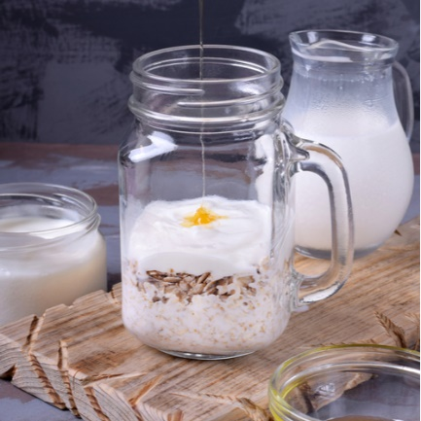
Ingredients:
½ cup rolled oats
1 cup non-dairy milk (almond, oat, soy) or A2 milk
½ cup blueberries or blackberries
½ banana
1 tbsp chia seeds
1 tbsp walnuts
½ tsp cinnamon and/or ginger, optional
1 tsp pure maple syrup, optional

Instructions:
- Combine ingredients in a jar/bowl and stir well
- Cover and refrigerate overnight
- In the morning, heat if desired
- Top with 1/4 cup Greek yoghurt

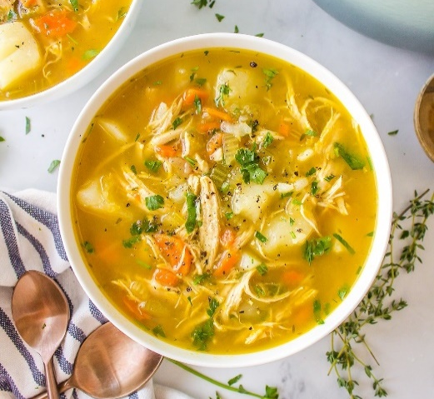
Bone Broth Chicken and Vegetable Soup
Serves: 4
Ingredients:
- 2 tbsp olive oil
- 2 medium carrots, peeled and chopped
- 2 celery stalks, chopped
- 1 medium onion, peeled and chopped
- 2 cloves garlic, minced
- 8 cups chicken bone broth
- 1 bay leaf
- A few sprigs of fresh thyme
- 1 tbsp curry powder
- Salt and pepper, to taste
- 2 boneless, skinless chicken breasts
- 1 sweet potato, peeled and cubed
- Add brown rice noodles to serve if desired

Instructions:
- In a large pot, heat the olive oil over medium-high heat.
- Add the chopped onions, carrots, and celery. Cook, stirring frequently, for about 5-7 minutes, or until the vegetables start to soften and the onions become translucent.
- Add the minced garlic to the pot and cook for an additional 30 seconds, or until fragrant.
- Pour in the 8 cups of prepared chicken broth into the pot with the sautéed vegetables.
- Add the bay leaf and sprigs of thyme to the pot. Bring the broth to a simmer over medium heat.
- Once simmering, carefully add the chicken breasts to the pot. Make sure they are submerged in the broth. Cook them for about 20 minutes, or until they are fully cooked through.
- Once the chicken breasts are cooked, remove them from the pot and place them on a cutting board. Using two forks, shred the chicken into bite-sized pieces. Return the shredded chicken to the pot.
- Add the curry powder and cubed sweet potato to the pot and season with salt and pepper to taste.
- Let the soup simmer for an additional 20-30 minutes, or until the potatoes are tender.
- Turn off the heat and use tongs to remove the bay leaf and thyme sprigs and discard.
- Before serving, taste the soup and adjust seasonings as needed.
- Ladle the soup into bowls and serve hot. (If using, add cooked noodles to bowl before serving soup on top)

Salmon Poke Bowl

Serves: 2

Ingredients
- 1 cup black or brown rice
- 1 tbsp tamari sauce
- 1 tbsp rice vinegar
- 2 tsp sesame oil
- 2 tsp finely grated ginger
- 200g smoked salmon
- ½ cup edamame beans
- 1 cup kale, shredded
- 1 medium carrot, grated
- ½ cup red cabbage, shredded
- 4 seaweed sheets, crumbled on top
- Pickled ginger to serve

Instructions
- Cook rice as per packet directions
- Stir tamari sauce, vinegar, sesame oil and ginger in a medium bowl. Reserve ½ in another bowl. Add salmon to bowl and stir until coated. Refrigerate for 20 min.
- Prepare edamame as per directions (depends on if canned, frozen or fresh is purchased)
- Divide rice among bowls, then top with kale, carrot, cucumber, cabbage, edamame and salmon. Drizzle with the remaining dressing.
- Add seaweed and pickled ginger.

Fish Tacos
Serves: 4
Ingredients:
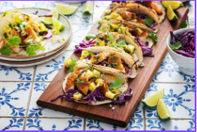
For the slaw
- 2 tbsp diced red onion
- 1 cup shredded purple cabbage
- 2 tbsp coriander, chopped
- 1 tbsp lime juice
- 1 tbsp olive oil
For the sauce
- 1/3 cup coconut or Greek yoghurt
- 1 tbsp lime juice
- 1 tsp garlic powder
- 2 tsp coriander, chopped
For the fish
- 2–3 tbsp coconut oil
- 1/2 tsp sea salt
- 1/4 tsp black pepper
- 2 tsp garlic powder
- 1 tsp onion powder
- 1/4 tsp chili powder
- 1/4 tsp cumin
- 4 white fish fillets
For serving
- 4-8 tortillas
- 1 avocado, diced
- Lime wedges
Instructions:
- Mix the ingredients for the slaw together and set aside.
- Combine the sauce ingredients and chill in the fridge.
- In a large deep pan over medium-high heat, heat the oil.
- Season the fish filets on both sides until well coated. Carefully place the fillets in the pan. Cook for 3-4 minutes on each side, carefully flipping to cook on all sides, until the fish easily flakes. Set aside.
- Assemble the tacos with the fish, slaw and avocado.
- Drizzle with sauce and serve with lime wedges on the side

Lime and Sesame Stir-fry
Serves: 4

Ingredients:
- 500g firm tofu (or chicken)
- 2 tbsp sesame oil
- 1 cup bean sprouts
- 2 cloves garlic
- 2 tsp minced ginger
- 1 cup snow peas
- 1 cup sliced red capsicum
- 1 cup broccoli
- ½ cup slivered almonds
- 1 tbsp lemon/lime juice
- 1 tbsp tamari
- 2 cups cooked brown rice or buckwheat noodles to serve

Instructions:
- Sauté tofu or chicken with ginger, garlic and tamari until cooked but not browned.
- Add vegetables and cook for two to three minutes.
- Add mix to bowl over cooked brown rice/noodles.
- Sprinkle slivered almonds over meal just prior to serving.
- Dress with lemon/lime juice and sesame oil

