
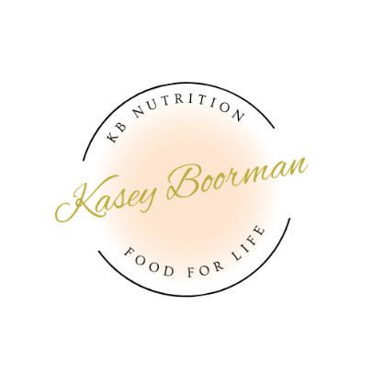
Wellness Analysis Summary

Client Name: Claire
Date: 25.7.24

Goal Weight: 67-70kgs.

The table below provides your current intake of all the macronutrients and any micronutrients that appeared out of balance. The third column lists the recommended intake based on the food diary you sent through, your height, weight, activity level and your goal.
The fourth column will show you the amount you are deficient in or in excess of.
The fifth column lists some foods that contain the nutrients you may like to include or remove from your diet.
A full graph with all Recommended Dietary Intake (RDI) comparison is also included for your reference.

Results

Nutrient | Current Intake | Recommended Intake | Deficit or Excess | Notes | Food Sources
Energy (Kilojoules) | 4126.7kJ  908 calories | 9300kJ  2250 calories | -5173.3kJ  - 1230 calories | We need energy not only to fuel our bodies but for all physiological processes inside our body. When we are under eating, we can have trouble with metabolism, hormones and reproductive system, energy (fatigue), mood disturbances, digestive issues and more. When the goal is weight loss it can be hard to justify eating more, however, it can help by resetting hunger hormones & metabolism. Adequate energy is also required for conception.
Carbohydrates | 61g  (over 50% sugar) | 250g minimum | -189g | A prime source of energy for our bodies. Carbohydrates also contribute to mood and sleep significantly. | Wholegrain bread, pasta, brown rice, sweet potato, potato, fruit, vegetables, legumes, crackers  AVOID: processed foods, ice-creams, milk chocolate, lollies etc.
Protein | 63.9g | 128g | -67g | Protein is your weight loss friend! It helps to regulate metabolism, support healthy weight management, and promote feelings of fullness. It is also essential for hormone production. | Animal products – meat, dairy, eggs  Plant sources (usually less protein) – beans, legumes, nuts, seeds
Fat | 43g | 50g minimum | Almost there. | Healthy fats are needed for hormone production, digestion and absorption of minerals. This will improve as more food is added. | Avocado, olive oil, meat, dairy, nuts, nut butters, oily dressings  Omegas - Seafood, flaxseed, chia seeds, walnuts  soy, hemp seeds, eggs
Fibre | 5.8g | 25g | -19.2g | Fibre helps to promote regular bowel movements and prevent constipation by adding bulk to the stool. Fibre also helps to slow down the absorption of sugar in the bloodstream, which can help to regulate blood sugar levels and prevent spikes (moods, fatigue, weight gain). Fibre is filling and can help to control appetite and reduce calorie intake, which is beneficial for weight loss. | Beans, lentils, broccoli, wholegrains, fruit, avocado, vegetables

Nutrient | Current Intake | Recommended Intake | Deficit or Excess | Notes | Food Sources
Calcium | 638mg | 1000mg | -362mg | Healthy bones, heart, muscle and nerves  Release of certain hormones and enzymes that are involved in metabolism and digestion.  Regulates hormone levels in the body, including those involved in ovulation and fertility. | Dairy products (milk, cheese, yoghurt), edamame, sesame seeds, almonds
Folate | 212ug | 400-600ug | -182ug | Folate is essential for preconception because it plays a crucial role in a healthy pregnancy and fetal development. | Dark green leafy vegetables, beans, peas and nuts, oranges, lemons, bananas, melons and strawberries.
Iodine | 111ug | 150ug minimum | -39ug | Essential component of thyroid hormones which controls our metabolism.  Prior to conceiving, thyroid hormones regulate ovulation, as well as metabolism and weight management - all important factors in improving your chances of getting pregnant naturally.  Once pregnant, iodine is particularly important for a developing foetus as the thyroid hormone is also involved with brain development. | Seafood, seaweed, iodised salt, dairy
Iron | 5mg | 18mg | -13mg  Pathology also showed low iron stores | Fatigue, cognitive function - production of neurotransmitters such as dopamine and serotonin (mood).  Adequate iron levels are important for maintaining healthy blood and oxygen levels, which are crucial for supporting a healthy pregnancy.  Iron plays a role in cell growth and DNA synthesis, which are important for the development of a healthy baby. | Meats, poultry and seafood are your best sources.  Plant sources - fortified grains, nuts, seeds, legumes, and vegetables
Vitamin C | 14.5mg | 45mg | -30.1mg | Aids absorption of iron, immune function.  For women, vitamin C helps regulate hormone levels, improve the health of the reproductive system, and increase the chances of ovulation. It also acts as an antioxidant, protecting eggs from damage caused by free radicals.  For men, vitamin C has been shown to improve sperm quality by reducing DNA damage and increasing sperm motility. It also helps protect sperm from oxidative stress, which can affect fertility. | Citrus fruits (orange, kiwi, lemons, guava, grapefruit), red capsicum, broccoli, cabbage, cauliflower, tomatoes, strawberries

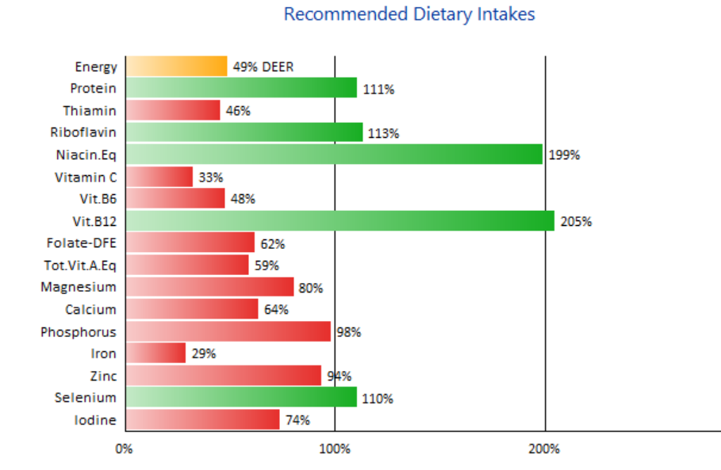
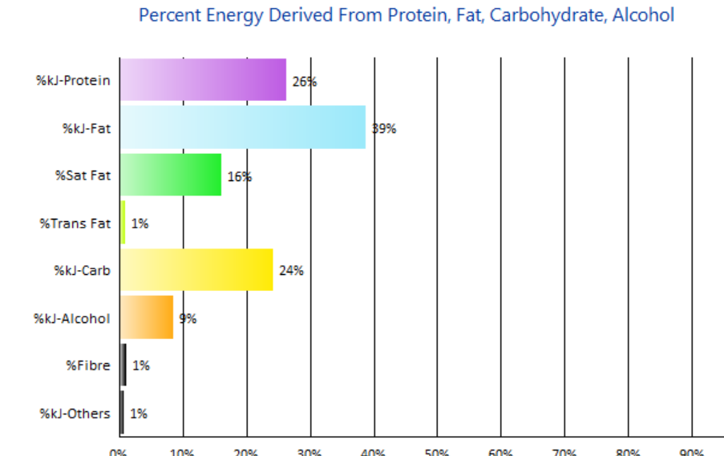
Results from 3 day food diary (graphs)

Ideally your ratios should look more like Protein: 25%, Fat 25%, Carbohydrate 50% (fruit, veg, wholegrains).
Increasing more food overall will increase most nutrients. Choose protein and vegetables first.

Preconception Nutrients of Interest
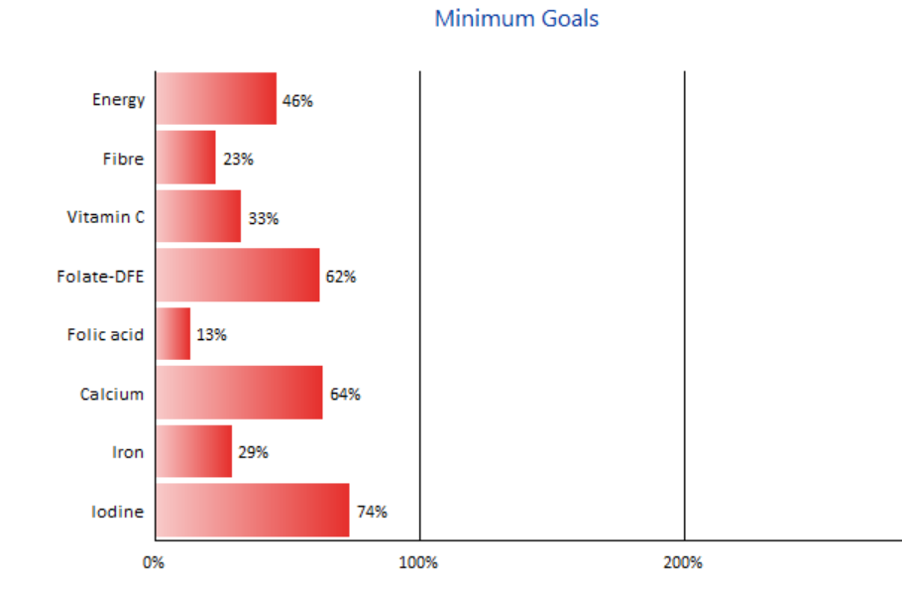

Pathology Results
- Ferritin – 20ug (we want 50ug minimum)
Indicative of iron stores. Possibly not eating enough iron or not absorbing well (gut, pairing combinations (vit C, avoid tannins). Low iron is linked to fatigue, poor mood, conception
- Sodium – 136 mmol/L (137 minimum)
Sodium helps regulate water balance in/out of the body and cells. Low levels due to stress, adrenal insufficiency or kidney health (other kidney markers are in range).

