
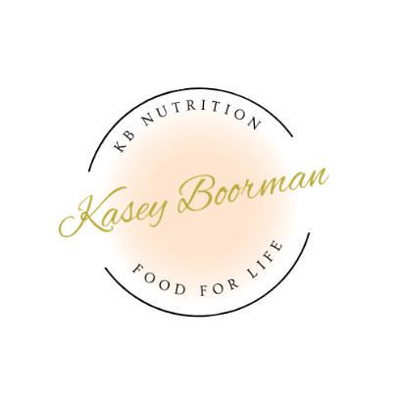

Client Name: Sandra Barnett
Date: 24.7.24

Health Priorities
Anti-inflammatory Diet – reduce eczema flare up
Principles of anti-inflammatory diet

- Include oily fish such as Salmon, Tuna, Trout, Mackerel at least 3 times per week
- Reduce beef, lamb and pork to once per week
- Include lean chicken or turkey at least 3 times per week
- Include the following herbs and spices: Celery seeds, chamomile, cinnamon, fennel, garlic, ginger, rosemary, turmeric
- Avoid the following herbs and spices: Reduce salt, sugar, artificial sweeteners, colours, flavours and preservatives.
- Include 3-5 serves of vegetables per day (vary as much as possible)
- Include 2 serves of fruit per day
- Include 1-2 tbsp of olive oil per day (to cook with, as a dressing etc.)
- Include 1-2 serves of nuts and seeds per day (any raw nuts except peanuts)
- Include up to 4 serves of grains/legumes per day (reduce wheat/gluten products). Choose mostly brown rice, quinoa, buckwheat, corn, rice noodles, chickpeas, lentils, legumes (beans)
- Reduce sugar as much as possible
- For now, avoid eggs, tomatoes, deep fried foods
- Include 2L water per day
- Reduce coffee to one per day (no sugar)
- Include up to 2 serves dairy per day (avoid cow’s products where possible, choose goat or sheep cheese, A2 milk or plant-based milk, Greek yoghurt is OK)
Lifestyle Considerations:
- 2 x weight bearing exercise session per week
- 3 x aerobic exercise sessions per week
- Reduce alcohol – aim for 2-3 per week maximum if cannot be removed for 6 weeks. Choose red wine ideally
- Relaxation techniques such as mindfulness meditation, reading before bed, white vinegar bath,
- White vinegar spray after showers (2 times per day, regardless of if had 2 showers)
- Use coconut oil after white vinegar spray

Lifestyle interventions such as these have been shown to be anti-inflammatory, reduce pain, as well as improve resilience, sleep and overall wellbeing.
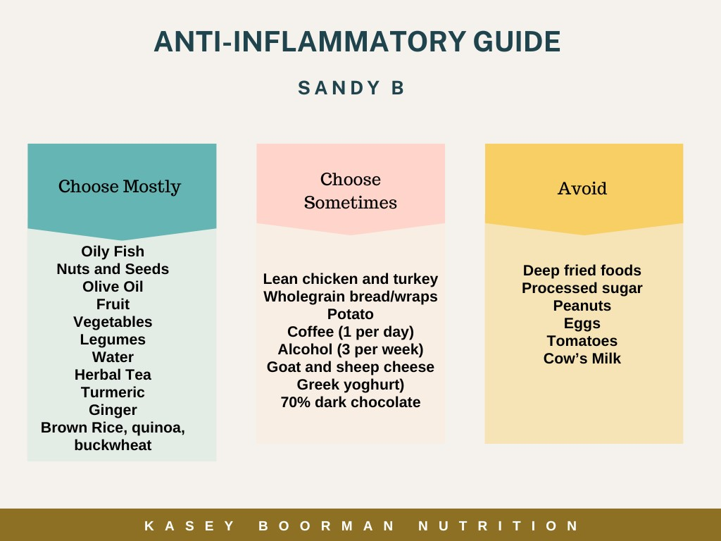

See attached one-week suggested meal plan
Recipes:
Overnight Oats
Serves 1: Multiply by how many mornings you want to have it within 5 days
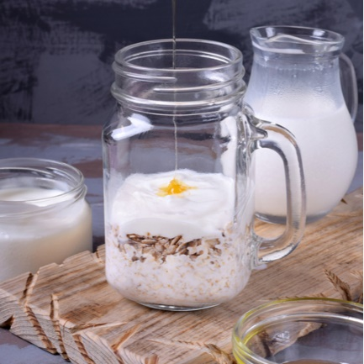
Ingredients:
½ cup rolled oats
1 cup non-dairy milk (almond, oat, soy) or A2 milk
½ cup blueberries or blackberries
½ banana
1 tbsp chia seeds
1 tbsp walnuts
½ tsp cinnamon and/or ginger, optional
1 tsp pure maple syrup, optional

Instructions:
- Combine ingredients in a jar/bowl and stir well
- Cover and refrigerate overnight
- In the morning, heat if desired
- Top with 1/4 cup Greek yoghurt

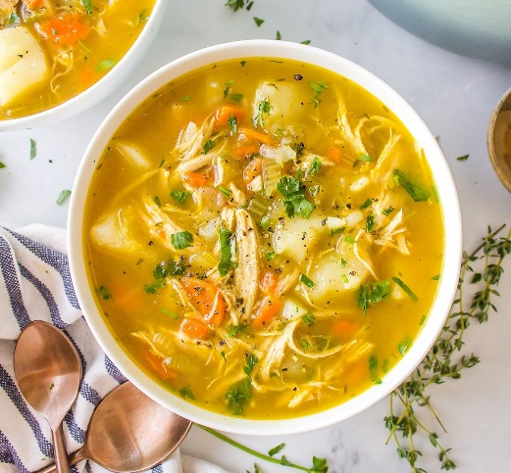
Bone Broth Chicken and Vegetable Soup
Serves: 4
Ingredients:
- 2 tbsp olive oil
- 2 medium carrots, peeled and chopped
- 2 celery stalks, chopped
- 1 medium onion, peeled and chopped
- 2 cloves garlic, minced
- 8 cups chicken bone broth
- 1 bay leaf
- A few sprigs of fresh thyme
- 1 tbsp curry powder
- Salt and pepper, to taste
- 2 boneless, skinless chicken breasts
- 1 sweet potato, peeled and cubed
- Add brown rice noodles to serve if desired

Instructions:
- In a large pot, heat the olive oil over medium-high heat.
- Add the chopped onions, carrots, and celery. Cook, stirring frequently, for about 5-7 minutes, or until the vegetables start to soften and the onions become translucent.
- Add the minced garlic to the pot and cook for an additional 30 seconds, or until fragrant.
- Pour in the 8 cups of prepared chicken broth into the pot with the sautéed vegetables.
- Add the bay leaf and sprigs of thyme to the pot. Bring the broth to a simmer over medium heat.
- Once simmering, carefully add the chicken breasts to the pot. Make sure they are submerged in the broth. Cook them for about 20 minutes, or until they are fully cooked through.
- Once the chicken breasts are cooked, remove them from the pot and place them on a cutting board. Using two forks, shred the chicken into bite-sized pieces. Return the shredded chicken to the pot.
- Add the curry powder and cubed sweet potato to the pot and season with salt and pepper to taste.
- Let the soup simmer for an additional 20-30 minutes, or until the potatoes are tender.
- Turn off the heat and use tongs to remove the bay leaf and thyme sprigs and discard.
- Before serving, taste the soup and adjust seasonings as needed.
- Ladle the soup into bowls and serve hot. (If using, add cooked noodles to bowl before serving soup on top)

Salmon Poke Bowl

Serves: 2

Ingredients
- 1 cup black or brown rice
- 1 tbsp tamari sauce
- 1 tbsp rice vinegar
- 2 tsp sesame oil
- 2 tsp finely grated ginger
- 200g smoked salmon
- ½ cup edamame beans
- 1 cup kale, shredded
- 1 medium carrot, grated
- ½ cup red cabbage, shredded
- 4 seaweed sheets, crumbled on top
- Pickled ginger to serve

Instructions
- Cook rice as per packet directions
- Stir tamari sauce, vinegar, sesame oil and ginger in a medium bowl. Reserve ½ in another bowl. Add salmon to bowl and stir until coated. Refrigerate for 20 min.
- Prepare edamame as per directions (depends on if canned, frozen or fresh is purchased)
- Divide rice among bowls, then top with kale, carrot, cucumber, cabbage, edamame and salmon. Drizzle with the remaining dressing.
- Add seaweed and pickled ginger.

Fish Tacos
Serves: 4
Ingredients:
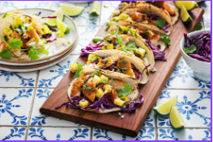
For the slaw
- 2 tbsp diced red onion
- 1 cup shredded purple cabbage
- 2 tbsp coriander, chopped
- 1 tbsp lime juice
- 1 tbsp olive oil
For the sauce
- 1/3 cup coconut or Greek yoghurt
- 1 tbsp lime juice
- 1 tsp garlic powder
- 2 tsp coriander, chopped
For the fish
- 2–3 tbsp coconut oil
- 1/2 tsp sea salt
- 1/4 tsp black pepper
- 2 tsp garlic powder
- 1 tsp onion powder
- 1/4 tsp chili powder
- 1/4 tsp cumin
- 4 white fish fillets
For serving
- 4-8 tortillas
- Lime wedges
Instructions:
- Mix the ingredients for the slaw together and set aside.
- Combine the sauce ingredients and chill in the fridge.
- In a large deep pan over medium-high heat, heat the oil.
- Season the fish filets on both sides until well coated. Carefully place the fillets in the pan. Cook for 3-4 minutes on each side, carefully flipping to cook on all sides, until the fish easily flakes. Set aside.
- Assemble the tacos with the fish and slaw
- Drizzle with sauce and serve with lime wedges on the side

Lime and Sesame Stir-fry
Serves: 4

Ingredients:
- 500g firm tofu (or chicken)
- 2 tbsp sesame oil
- 1 cup bean sprouts
- 2 cloves garlic
- 2 tsp minced ginger
- 1 cup snow peas
- 1 cup sliced red capsicum
- 1 cup broccoli
- ½ cup slivered almonds
- 1 tbsp lemon/lime juice
- 1 tbsp tamari
- 2 cups cooked brown rice or buckwheat noodles to serve

Instructions:
- Sauté tofu or chicken with ginger, garlic and tamari until cooked but not browned.
- Add vegetables and cook for two to three minutes.
- Add mix to bowl over cooked brown rice/noodles.
- Sprinkle slivered almonds over meal just prior to serving.
- Dress with lemon/lime juice and sesame oil

