CASSIE HOWER  HERBALIST  PLANTS + PASSION  cassie@plantsandpassion.com  www.plantsandpassion.com.au  DATE: 30.7.24  NAME: Eve Hunt  CONSULT: Initial consult – in person | 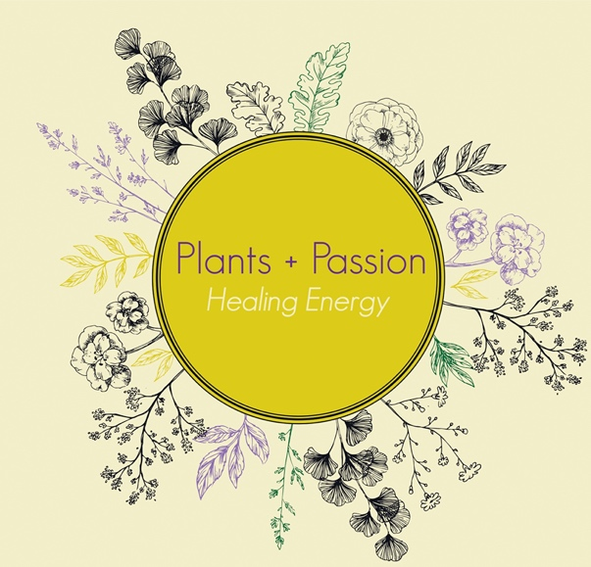

Medications and safety issues:
(pregnancy, lactating, allergies)

Nil

OCP – age 11 to 17 (5-6 years) Evelyn
Pregnant – no

Allergic to most fruit and vegetables, nuts – mild reactions – tingly mouth and feels like it’s on fire
3/10
Carrots and watermelon are worse than anything else – avoids
Hasn’t noticed any reactions to onion or garlic
Hayfever worse in the past, improved – was constant when younger

Presenting complaint:

Anxiety, depression, menometrorrhagia

Menarche at 8
Started getting bad around 10/11

Family history:
Mum’s cycles were pretty bad but not as bad as hers – irregular, painful cramps
Sister cramps with heavy bleed and emotional

History is sexual abuse (rape)

Lifestyle

Sleep – 6 hours 8/9pm to bed, asleep around 10ish most nights, waking at 3:30/4am for work

Physical at work – heavy lifting, moving around at lot, sometimes to the gym – feels she’s very active – will be walking to and from work from next week

Very rarely drinks alcohol
Nil recreational drugs
Addicted to speed and party drugs age 13-15
Smoked since 11 – vapes occasionally twice a week fruit/nicotine mix – hard to quit – but wants to

Zero contact with family
Mother cut off contact – also cut off contact with her younger sisters (5, 6 and 14) – she misses them. Sees the 14 year old occasionally
She cut off contact with her dad – not a good relationship so this is for the best
Nil support
Nil friendships

Likes work – they’re a great company

Likes to read and play with cats
Physics and politics – non-fiction
Russian literature

Diet
Breakfast – nil
Lunch – nil most days – weetbix with cows milk or leftovers from dinner night before
Dinner – steak and vegetables to noodles – always changing
No snacks
Water 2-3L/day
Coffee 2-3 coffees/day all before 7:30am
Apples – only fruit she tends to eat
Reacts to bananas but still eats them sometimes

Send some recipes

Systems

GIT: All through menstruation stools are green/black (only when bleeding), regular brown other times – regularly once daily (after work at home), 3-4 daily with menstruation, Bristol BM 3-4, 2-3 when menstruating, smell is worse when menstruating,

Nervous: worse with menstruation, stuck in thoughts, overthinking, crying, trying to think of how to improve life, loneliness, friends and family don’t want her, tends to get stuck in all of that – physically reacts to all of this when she’s bleeding but handles it well when she’s not
Feeling like shes about 5/10 in her life at the moment but not cycling and always much worse during bleeds

Working on mindset has helped
Seeing lessons in her trauma and past experiences

Immune/respiratory:

Hepatobiliary:

Integumentary:

Renal/Urinary:

Female repro:
Irregular, surprise, sometimes a week break in between, sometimes four weeks
Symptoms start a week or a week and a half before and sometimes a week after stopping bleeding
While body gets really sore, headaches, eyes and ears hurt (sensitive to loud noises and sight), badly constipated, fingers and toes hurt, sometimes vomit, feels worse with eating, extremely dehydrated (drinks a lot of water), decreased appetite
These symptoms can go on for three weeks – “feels like I’m dying but just need to go about life as normal”
Bleeds generally 6-10 days
Very very heavy
Uses pads – Extra overnight (even during the day) – not changing overnight but very full and leaky early in the morning – changing 2-3 during the day – towards the end dies down a little but still heavy
Moves bowels 3-4/day
Dark red (not bright red)
Last 2-3 days brownish colour
Sometimes it comes in straight away, other times it comes in brown then turns red
A lot of cramping
Stabbing pain around the vulva area
Worse for standing (maybe)
Sometimes her whole body just aches
Clots up to 20c piece
Often pea size
Increased depression and anger and stress goes up – anxiety – normally

Etc:

Look into support groups –
Stardust app
Hot water bottle

