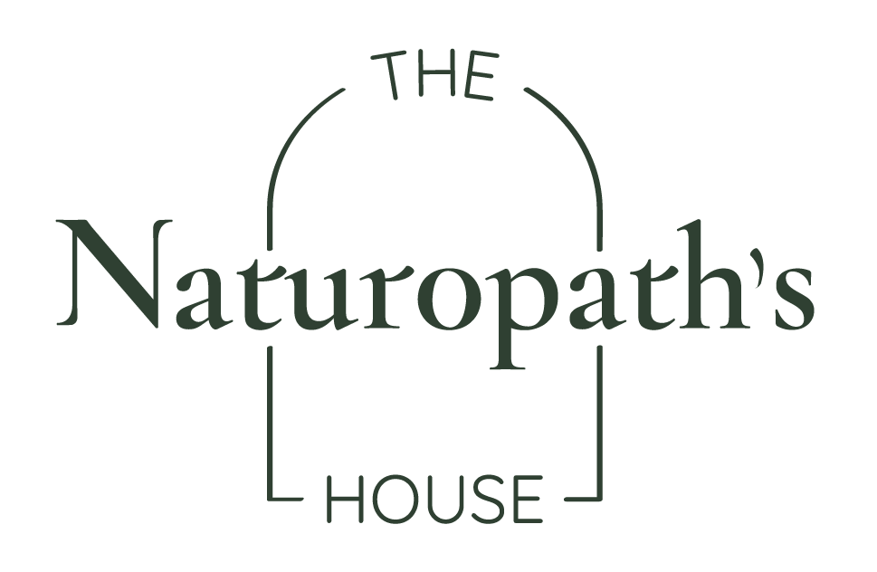
Name: Maria Teresa Gomez
Date: 10th September 2024

Wellness Plan ~
Dietary Recommendations (to implement a more healthful regime and solid nutrition base):

- Invest in clean water – The quality of our water greatly impacts our overall health. Investing in a reverse osmosis water filter will remove common impurities (e.g., chloride fluoride, heavy metals, pesticides, and other pollutants). This will help reduce the body’s daily toxin load, including that experienced by the thyroid.
- Choose spray free or organic produce where possible. This will ensure you eat real food that is both local and seasonal. The produce is naturally ripened, more nutrient dense, and will minimises your exposure to synthetic pesticides, again supporting the thyroid.

Lifestyle Recommendations (to encourage the healing power of nature):

- Implement a daily grounding technique – this involves just sitting/standing on the earth (barefoot) for however long feasible for your daily lifestyle. Direct physical contact with the surface of the planet has been termed ‘electric nutrition’. The practise works by reorientating the body to the global electrical circuit, exerting full body benefits: pH balance, anti-inflammatory and antioxidant effects have been noted in research.
- Honour sunrise and natural sunlight: Aim to expose your bare eyes (i.e., not with sunglasses or through windows) and a seasonally appropriate amount of skin to the sun for 5-20 minutes at sunrise and sunset, and 5-10 minutes of midday sun. Natural sunlight is the strongest factor in resetting our circadian rhythm cues.
Supplement Recommendation (to support body system/s and address current signs and symptoms)
Product | Breakfast | Lunch | Dinner
Enduracell | Enough to fill tip of a sharp knife in a small amount of water
*Working your way up to 1 full scoop in the coming weeks.

Initial Treatment Aims:
- Optimise circadian rhythm for both bone and thyroid health
- Introduce grounding/earthing to aid with inflammation/acidity within the body; supporting immune/thyroid and bone health.
- Start to reduce dietary toxins (specifically glyphosate and fluoride)
- Start addressing Hashimoto’s by ‘turning up’ our protective cell mechanism and ‘turning down’ oxidative stress and excess inflammation
- Support bone health by aiding vitamin D status, activate osteoblast (bone building) activity, and lifestyle changes.
Follow up aims:
- Review progress to wellness – progress and adjust as required
- Review mineral therapy questionnaire and implement indicated mineral therapies.

Next appointment: 5 weeks

