
12/09/2024
Pivot Movement
308 Walcott Street Menora 6050
Dear Sir/Madam

Mrs Lorraine Sophie Defleur 21/12/1970
We are writing to inform you that we wish to engage your services as per the attached GP
Management Plan and Team Care arrangements for Mrs Lorraine Sophie Defleur
It is now a requirement that we receive a written or verbal confirmation from Allied Health providers prior to referring patients. This ensures that you are willing to accept a referral and treat the patient as per the goals of the attached GP Management Plan.
Allied Health Provider Signature:

Please sign and fax back to Floreat Forum General Practice on 9269 9028.
Yours sincerely
Dr Samuel Mansour
467343MK
Floreat Forum Shopping Centre, 5 Howtree Place, Floreat WA 6014
Postal Address: PO Box 455, Floreat WA 6014 Tel: (08) 9269 9029 Fax: (08) 92699028
Email: reception@ffgp.com.au
Australian Gmentment
Referral Form for Individual Allied Health Services under Medicare for patients with a chronic medical condition and complex care needs
Note: GPs can use this form issued by the Department of Health and Ageing or one that contains all of the components of
this form.
To be completed by referring GP.'
Please tick: Note: GPs are encouraged toattach a copy of the relevant part of the patient's care plan to this form.
Patient has GP Management Plan (item 721 ) AND Team Care Arrangements (item 723) OR
GP has contributed to or reviewed a multidisciplinary care plan prepared by the patients aged care facility (item 731)
Medicare rebates and Private Health Insurance benefits cannot both be claimed for these services. Patients should be advised that they must choose whether to access one or the other.
GP details
ProviderNo. | 467343MK
Name | Dr Samuel Mansour
Address  Patient details  Medicare No | Shops 9,10 & 17 Floreat Forum  5 Howtree Place Floreat WA  6256695452 Ref 1 Exp 04/2026 |  | Postcode 6014
First Name | Lorraine | Surname | Defleur
Address  Phone  Allied Health  Name | 46 Herdsman Parade Wembley WA  H W M 0404 312 768  Pivot Movement |  |  | Postcode 6014
Address  Phone | 308 Walcott Street Menora WA  0449 500 165 |  |  | Postcode 6050
Referral details —Please use aseparatecopy of the referral form for each of service
Eligible patients mayaccessmedicarerebatesfor uptSallied health services (in total)in a calendar year. Indicate the numberffsejvices required by writing the number;intWe 'No. ofservices^{v}olumn nexttothe relevant AHP
No of |  | Item | No of |  | Item | No of
services | AHP Type | Number | services | AHP Type | Number | services | AHP Type | Number
 | Aboriginal Health Worker/Aboriginal and  Torres Strait Islander Health Practitioner | 10950 |  | Exercise Physiologist | 10953 |  | Podiatrist | 10962
 | Audiologist | 10952 |  | Mental Health Worker | 10956 |  | Psychologist | 10968
 | Chiropractor  Diabetes Educator  Dietitian | 10964  10951  10954 |  | Occupational Therapist  Osteopath  Physiotherapist | 10958  10966  10960 |  | Speech Pathologist | 1 0970
Referring General
Practitioner's signature
 |  | 10964  10951  10954 |  | Date signed 12/09/2024 |  |  | Speech Pathologist | 1 0970
The AHP must provide a written report to the patient's GP after the first and last service, and more often if clinically necessary.
Allied health professionals should retain this for record keeping and Medicare Australia audit purposes.
Allied health services funded by other Commonwealth or Statemerritory programs are not eligible for Medicare rebates under this initiative.
This form may be downloaded from the Department of Health website at VMN. health.gov.au/mbsprimarycareitems
THIS FORM DOESNOTHAVE TO ACCOMPANY MEDICARE CLAIMS
CHRONIC DISEASE MANAGEMENT
Team Care Arrangement: MBS Item 723
Patient's Name: Mrs Lorraine Sophie Defleur | Date of Birth: 21/12/1970
Contact Details: | Medicare No.:
46 Herdsman Parade Wembley 6014 Home Phone: Work Phone:  Mobile Phone: 0404 312 768 | 6256695452
Details of Patient's Usual GP:  Dr Samuel Mansour  Shops 9,10 & 17 Floreat Forum  5 Howtree Place  Floreat 6014 | Details of Patient's Carer (if applicable):
If the patient has a previous or existing care plan, when was it prepared and what were the outcomes?
On: 14/03/2023 By: Dr Samuel Mansour
Other notes or comments relevant to the patient's care planning:
Medications:
No regular medications.
Allergies:
Nil known.
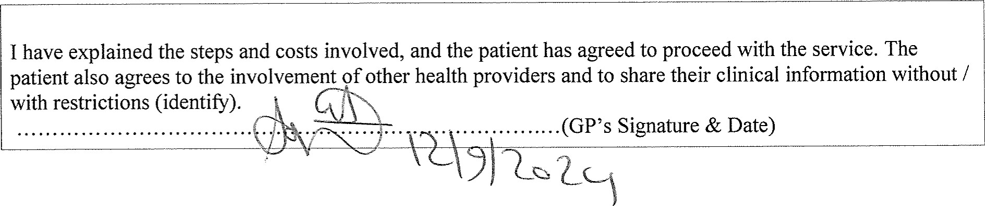
Page 1 of 3 Lorraine
Patient's Name: Mrs Lorraine Sophie Defleur
Patient problems / needs / relevant conditions
Bursitis, subacromial Frozen right shoulder Impingement.
Calcification within the subscapularis tendon.
Goals - changes to be achieved.
Improve general health (pain impacting day to day activities)
Improve knowledge of condition
Improve mobility (patient is an artist and pain is impacting ability to work)
Improve shoulder function Increase exercise tolerance
Prevent complications
Reduce rate of progression of injury
Reduce pain (8-9/10)
Required treatments and services.
Task |  | Provider |  | Due
 | Review by GP  Referral for Radiology  Referral for Physiotherapy  Imaging investigation  Physiotherapy  CT guided glenohumeral joint injection  Exercise program  Imaging investigation |  | G.P.  G.P.  G.P. G.P.  Pivot Movement  SKG  Pivot Movement  SKG |  | 12/09/2024  12/09/2024  12/09/2024  12/09/2024  12/09/2024  12/09/2024  12/09/2024  12/09/2024
 | Arrangements for treatments/services.
 | Provider |  | Phone |  | Fax

Pivot Movement
SKG
Copy of TCA offered to patient? No
TCA added to the patient's records? Yes
Date service was completed: 12/09/2024
Page 2 of 3
0449 500 165
94890800 63802036
Copy / relevant parts of the TCA supplied to other providers? No
Referral forms for Medicare allied health and dental care services completed? Yes Review Date: 13/03/2025
Lorraine

