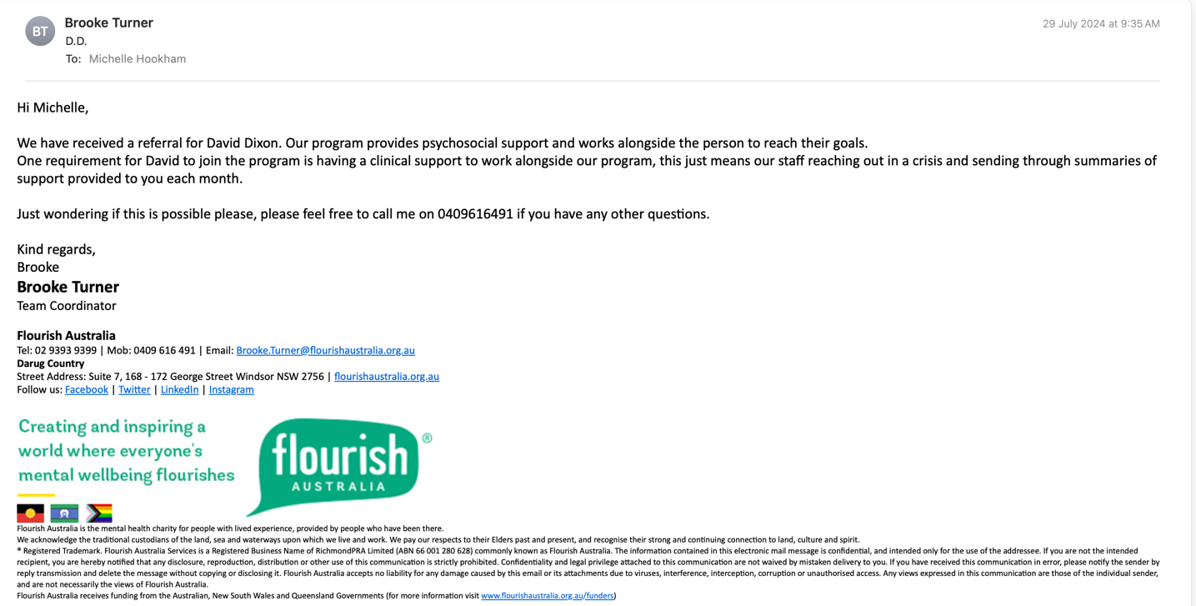

Follow up:

Dave’s referral to me was closed on the 20th of September, following his review and discussion of his care needs. I subsequently realised he needed that referral to be part of Flourish.

23.09.24
Phoned Brooke to discuss the situation. She advised that he needs to be linked with a clinician to meet the criteria to be part of the program. She is seeing Dave on Friday and will discuss this with him; he can choose to have his GP as that contact person, or myself, in which case he will need to arrange another referral.

