CASSIE HOWER  HERBALIST  PLANTS + PASSION  cassie@plantsandpassion.com  www.plantsandpassion.com.au  DATE: 2 October 2024  PRESCRIPTION FOR:  Natalia Sojak | 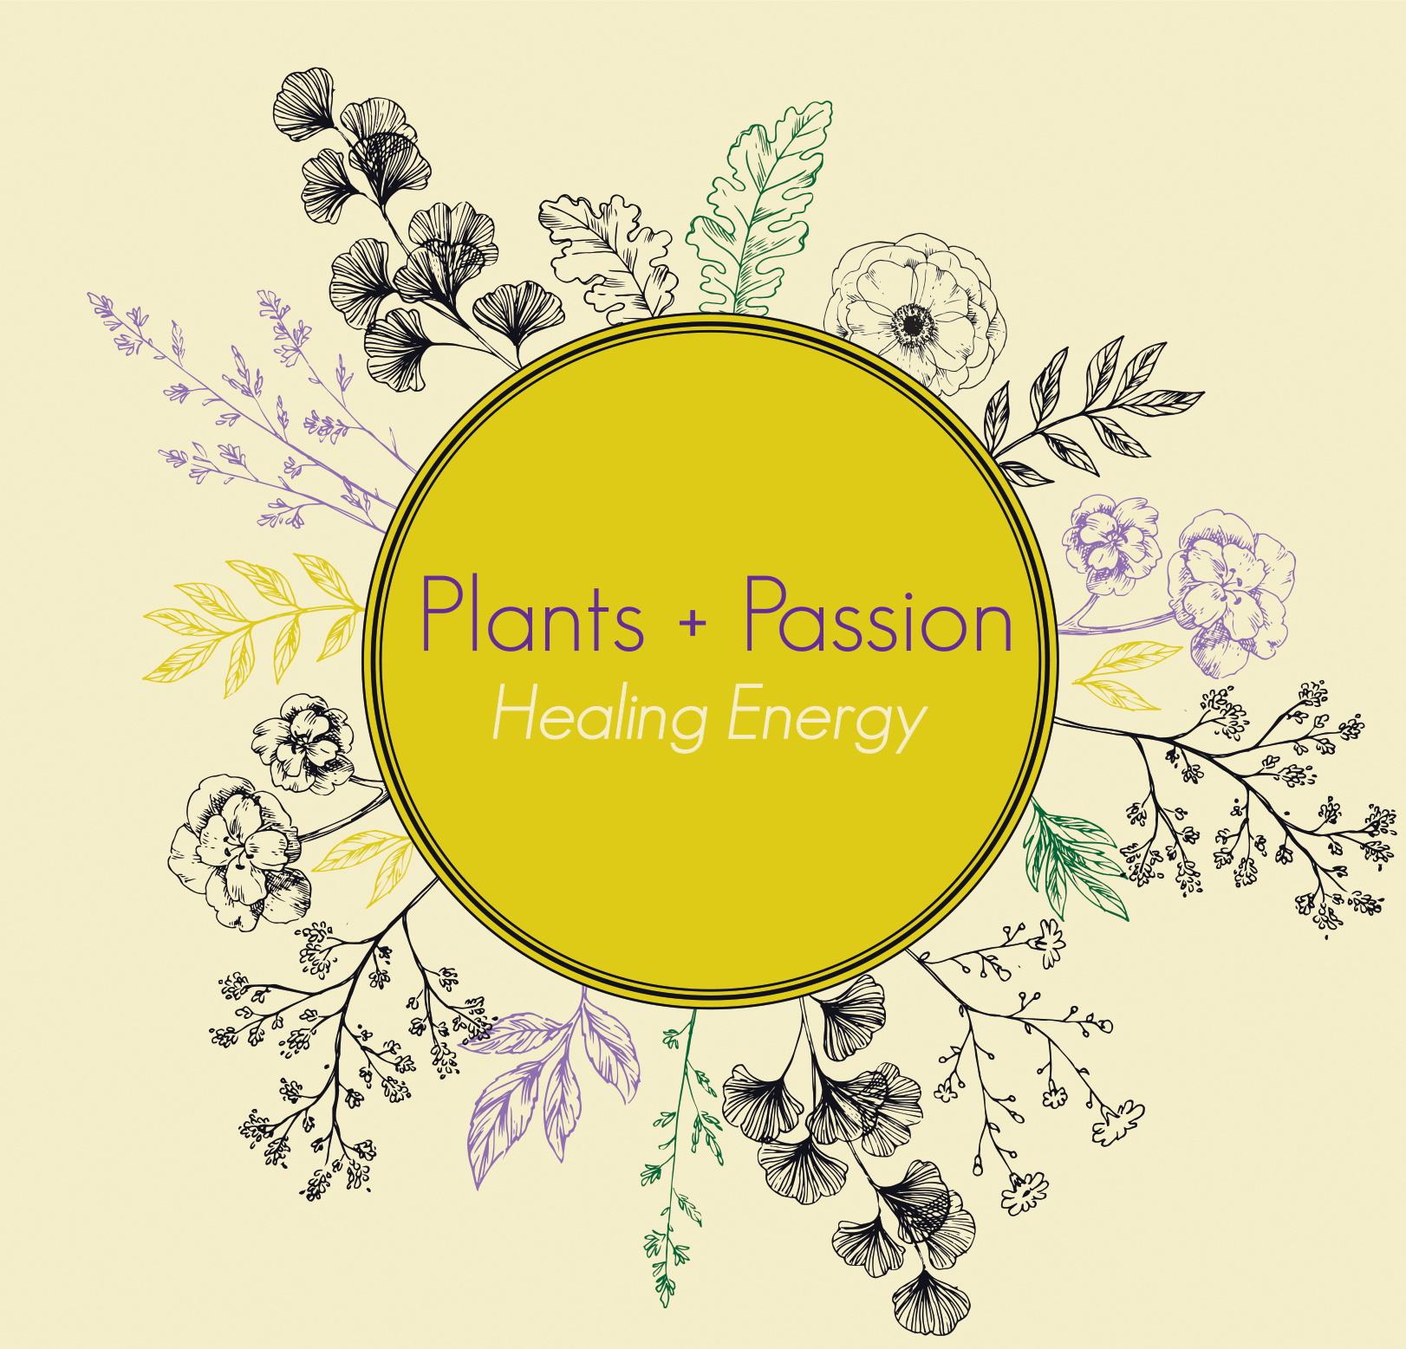
Treatment aims:

- Support and modulate immune system function
- Support adrenals and nervous system
- Improve digestive function (increase motility) and optimise clearing waste

HERBAL BLEND:

Globe artichoke – digestive and hepatobiliary support
Echinacea – immune modulation, also lymphatic
Licorice – sooth mucous membrane and tonify adrenals
Withania – nervine, adaptogen, immune modulation
Panax ginseng – adaptogen, immune modulation, increase energy

Take 2.5ml morning and lunch or afternoon with food in 20ml of water (taking in the evening could be too stimulating)

Start with 2.5ml but feel into the best dosage for your body – please reach out if you’d like to discuss changing your dosage – we can go up or down as needed – it’s best to feel into your individual body for dosage. Less is sometimes more!

Digestive drops:
Ginger and Gentian (on hand from Caroline) – dose as per her instructions to Jakub. Generally
6-20 drops in 20ml water before eating (or after eating if feeling bloated)

Additional herbs:

Eliana: Passionflower glycetract simple (single herb), small amount of California Poppy

Jakub: Chamomile glycetract and Lemonbalm

Each take 5-10 drops in 20ml water, 20-30 minutes before bed

The above herbs are not limited to treating what I have listed above, however I wanted to show you why I chose these particular herbs for you. All herbs and their constituents work in synergy together within a blend to bring harmony and balance where needed.

DIET AND LIFESTYLE:
- If you feel it could be helpful and supportive, please complete attached diet diary and return by email to cassie@plantsandpassion.com
- Take coffee after breakfast instead of before to support adrenal health
- Try switching a coffee for a roasted dandelion and chicory “coffee” (tea hehe) – this will support liver and gallbladder along with digestion
- Ensure drinking at least 2L water/day including herbal teas
- Reduce alcohol consumption to 2 standard drinks per evening – share one bottle of wine instead of opening the second bottle
- Listen to Alcohol Explained by William Porter on Audible – very helpful resource in understanding how the body and mind are reacting to the consumption of alcohol
- Look at your calendar and work out the best time to start Metabolic balance (maybe when Eliana is on camp). Tell me when you are starting. Perhaps also tell Tammy so we can both help to keep you on track.
- Increase good fats from foods like ghee, olive oil, avocado, nuts, sardines and mackerel
- Aim to meditate once daily including affirmations – even just for five minutes – look into tapping (EFT)

