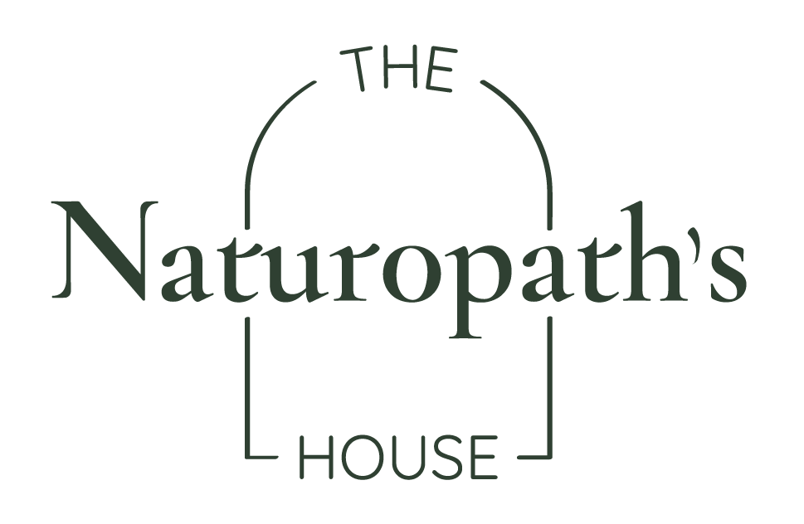
Name: Bec Monaghan
Date: 27.10.24

Wellness Plan ~

Establish foundation and conditions for health (via identifying and addressing current obstacles to health):

Additional pathology test considerations in pregnancy

- Vitamin D: Vitamin D is essential for baby’s healthy development, particularly bone and immune health/function. Deficiency is common in pregnancy.
- Iron studies: Iron plays a key role in normal foetal development. Iron needs go up during pregnancy and deficiency is common.
- Thyroid Panel: During pregnancy your thyroid gland ramps up production of hormones, to provide enough for both you and baby. Up until mid-pregnancy, your baby is entirely reliant on your thyroid hormones. Thyroid hormone is essential to the normal development of baby.
- Haemoglobin A1c: This test allows one to identify blood sugar issues/or good insulin sensitivity at the beginning of pregnancy, and take action early if required. Of note, the test not as accurate in the later stages of pregnancy due to natural hemodilution of your blood.

Dietary Recommendations (to implement a more healthful regime and solid nutrition base):

- Fertility ‘superfoods’ to include on your plate daily/weekly: Eggs including the yolk (protein, choline, DHA, vitamin A, E, D), *small* amounts of the liver (choline, iron, folate, B12, vitamins A, D, E, K), Meat on the bone (protein, B-vitamins, gelatine, collagen, glycine, trace minerals), Vegetables and leafy greens (antioxidants, fibre, B vitamins, vitamin K1, vitamin C etc.), well-sourced seafood (protein, DHA, iodine, selenium, zinc), full fat and fermented dairy products (protein, vitamins A, D, E, K, B-vitamins, probiotics).

Lifestyle Recommendations (to encourage the healing power of nature):

- The body speaks a somatic language, rather than a verbal one. Somatics is the language of ‘show me I’m safe’, ‘don’t tell me I’m safe’.

  - Breathing exercise: Physiological Sigh. 1. Get into a comfortable position 2. Take two inhales through your nose (the first long, the second shorter/sharper), 3. Give one long exhale through the mouth, 4. Repeat 3x
  - Massage Technique: Behind the Ear Massage. 1. Place your index finger behind the bottom back of your ear (in the valley behind your earlobe), 2. Massage from the bottom to top following the natural curve of your ear to the top, 3. Repeat on both sides for a few rounds. (Focus on moving the skin, versus applying pressure).
  - Vision Exercise: Lateral Eye Stretches. 1. With your head facing forward, move your eyes to the right for 30-90 seconds. You should be looking far enough to right that you feel a gentle stretch but not so far that it feels like you’re straining your eyes 2. Take a moment to notice whether you have any signs or reset 3. Repeat on the other side.

Supplement Recommendation (to support body system/s and address current signs and symptoms)
Product | Breakfast | Lunch | Dinner
Honest Health Co  Natal Support | 2 capsules with food
Fish Oil | To be advised
Trace Mineral | To be advised

Initial Treatment Aims:
- Support optimal nutrient intake from the diet to support your health and baby’s growth and development (dietary recommendations)
- Support additional nutrient requirements during this time of need (Prenatal + fish oil)
- Support your nervous system during times of change (Lifestyle recommendations)
- Aid in monitoring your health throughout each trimester (pathology testing, BP, blood sugar).
Follow-up aims:
- Review progress

Next appointment: 2nd Trimester

