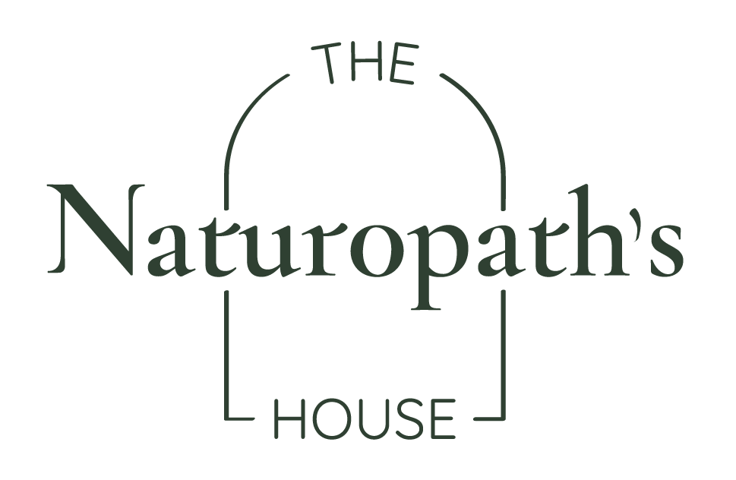
Name: Maria Teresa Gomez
Date: 8th April 2025

Wellness Plan ~

Dietary Recommendations (to implement a more healthful regime and solid nutrition base):
- Continue to incorporate Protein into Your Daily Eating Habits: Protein is the body’s "building block." Aim for around 1.2g of protein per kilogram of body weight, ideally over 70g daily. This is crucial for supporting energy levels, muscle repair, and bone strength.
- Continue to prioritise non-starchy Vegetables: Make non-starchy vegetables a priority at each meal, incorporating a variety alongside starchy or higher-carb options. This helps support a healthy gut, immune system, and antioxidant levels, all of which are particularly important for thyroid health.
- Continue to reduce toxin exposure: Opt for filtered water to reduce exposure to fluoride and other toxins; and wash your vegetables reducing glyphosate intake. These actions protect the thyroid gland from harmful substances.
- As always, progress over perfection!

Lifestyle Recommendations (to encourage the healing power of nature):
- Continue Building Healthy Habits: Continue practising grounding (gardening etc.) morning sunlight exposure to optimise your circadian rhythm and reduce excess inflammation. These habits are especially beneficial for bone health, thyroid function, and the immune system.
- Incorporate ‘Bone-Friendly’ Activities: Make bone-strengthening activities part of your daily/weekly routine. Aim for power walking three times a week, plus bodyweight exercises, resistance training (such as weights), dancing (like Zumba from your local council!), and balance training activities like yoga, tai chi, pilates, or stretching.
- Spend Time in the Sun (Sensibly): Make sure to spend some time in the sun to support healthy vitamin D levels. Vitamin D is essential for a balanced immune system and healthy bones.

Supplement Recommendation (to support body system/s and address current signs and symptoms)
Product | Breakfast | Lunch | Dinner
Cellugenex –  To support bone health, thyroid health and immune balance | 1.5 scoops in water/or unheated food (consumed immediately)
Active 4.3 | 1 tablet chewed | 1 tablet chewed | 1 tablet chewed

Current Treatment Aims:
- Support bone flexibility, balance and strength
- Support thyroid health; function, and integrity.
- Support healthy immune function (to aid with auto-immune Hashimoto’s).
- Order supplements from vital.ly as required.
Follow up aims:
- Review progress and adjust as required

Next appointment: 6 months

